**Soft Skills Development for Verve System Employees**

Global Team #2: Alpha Global

Members(Drexel University):

Panchani, Nirali

Koh, Timothy (Wei-Ming)

Sivan, Athira

Sachdev, Sahir

Leung, Wing Kin

Members(Amity University):

Tyagi, Akshat

Singh, Anjali

Gupta, Ankita

16 August, 2016

Final Project Report

Tables of Contents

Executive Summary………………………………………………………………..2

Introduction………………………………………………………………………...3

The Problem………………………………………………………………………..3

Approach...................................................................................................................3

1. Solution……………………………………………………………………...3
2. Deliverables…………………………………………………………………4
3. IT System Developed……………………………………………………….5
4. Project Assumptions………………………………………………………...6

Project Roles and Responsibilities…………………………………………………6

1. Project Organization Chart………………………………………………….6
2. Roles and Responsibilities of Team Member……………………………….7
3. Individual Contributions…………………………………………………….7

Team Member Hour Log…………...........................................................................9

Group Communication...........................................................................................11

Tools and Techniques……………………………………………………………..11

1. Tools………………………………………………………………………..11
2. Techniques……………………………………………………………….....12

Appendix………………………………………………………………………….14

Work Cited/References…………………………………………………………....47

**Executive Summary**

According to a NASCOM study, India’s IT sector is experiencing exponential growth. India’s technology and BPM sector (including hardware) is estimated to have generated US$146 billion in revenue during the financial year 2015 compared to US$ 118 billion in the financial year 2014, implying a growth rate of 23.72%in one year alone. The IT sector contributes to about 9.5% of India’s GDP according the analysis done in 2015. A combination a growing youth population and incredibly intelligent IT college graduates has allowed India to join the race with China in cornering the IT market in the world. It is estimated that India will outrace China in the next 20 years and become the premier IT country of the globe. Due to the high demand of Indian IT talent, it is highly important for those individuals to not only possess technical skills but also be well versed in business skills. Verve Systems Pvt. Ltd. is a Gujarat based IT company led by CEO Nitin Bawsay that is establishing itself as a premier international technology company during this time of economic prosperity in its sector. It possesses a team of highly skilled IT employees; the only problem being they needed to improve on soft skills.

Team Alpha Global strived to investigate common problems in soft skills. Through researching common workplace skills problems, surveying employees at Verve Systems Pvt. Ltd, and conducting employee interviews we explored in-depth about the general business problems that IT faces, especially from the perspective of an Indian firm.

From interacting with the employees and communicating frequently with CEO Nitin Bawsay and HR head Purvi Desai , Team Alpha Global partnered with individuals from Amity University to create a quiz in the form of a web-application that would identify the area of soft skills that the Verve Systems IT employees need to improve on. From that we strove to guide further soft skills development by providing video recommendations based on their performance.

Our final goal of developing a web application based survey was tested and hosted on Verve Systems website. It will be used by the HR department at Verve Systems to enhance employee soft skills and will help them identify soft skills requirements for potential employees.

**Introduction**

Verve Systems Pvt. Ltd. is an Information Technology Services and Product Development Company located in Ahmedabad, India. The company has many domestic and international clients that the employees in the IT Department have to interact with sometimes. While the IT employees have a high aptitude for technical skills, they lack a proficient level of business acumen. Verve Systems needs help in identifying the business soft skills that the employees need improvement on.

The primary purpose of this project was to create a quiz for the employees to take individually that would pinpoint the soft skills area that the employee needs improvement in. The questions for the quiz were compiled through consulting various online resources. After creating a quiz, a training recommendation was also requested. The focus of this project however, was to work mainly on the quiz that would identify the employees soft skills proficiency level. Creating or recommending training was a secondary part of the project. The project’s purpose was verified by Verve Systems CEO, Mr. Nitin Bawsay and the HR department head, Ms. Purvi Desai

**The Problem**

Verve Systems has clients in India and around the globe. Their IT employees are proficient in their work and have advanced technical skills. However, their soft skills need major improvement. IT employees need to incorporate exemplary soft skills when dealing with their international clients. IT employees would come into contact with the clients when making presentations on project deliverables. Verve Systems was also facing issues in making sure group dynamic soft skills for each employee were exemplary to maximize productivity and successful output during projects. Verve systems did not have a system in place they could use to test the soft skills of their employees and work on them. In addition, this module needs to be able to see the weaknesses in potential hires when Verve Systems is interviewing them to join the company. A recommendation needs to be given for the course of action to take in the training of the employees.. Soft skills of employees are a key aspect of a company’s image and in spite of not having much customer interaction, it is integral to develop soft skills.

**Approach**

1. To solve this problem, our team brainstormed for 2-3 sessions here at Drexel and came up with a solution. We suggested to develop a web application survey which would identify employees soft skills. This survey would consist of 5 different sections, which were a requirement.
   * Soft skills in that the modules we chose include, but are not limited to:
     + Communication
       - Body language
       - Dealing with international clients
     + Delegation
     + Self-Grooming
     + Stress Handling
     + Responsiveness

These sections were derived after consulting with Mr. Nitin Bawsay and conducting online research. We created a survey administered to 45 employees of Verve Systems. The questions were based on the soft skills categories chosen. Both of the sections and questions were approved by Mr. Bawsay and Ms. Purvi Dave, head of HR at Verve Systems. After analyzing the answers, we got further information on these 5 skills, we did one on one interviews with select employees from the survey. We picked a random sample of employees from the list to eliminate/minimize every possible bias. We could not interview all employees because of time constraints on both ends including work availability and time zone conflicts. Following this, we analyzed their answers and developed a web application collaborating with our technical team at Amity University. The final questionnaire will consist of 30 questions, 6 from each category. We believe that this number is a good amount to gauge an understanding of employees skills in each area, without them losing interest in the questionnaire. We have also spoken to Mr. Bawsay and Ms. Dave, who have approved of the questions. The employees would take the survey and based on their scores, it would be determined if they would require training or not. Links to the training videos will be attached to the survey results if training is a must. HR will be sent a copy of the results of the employees answers. They will also be able to use this survey for recruitment and hiring new employees, to assess their soft skills.

1. Deliverables
2. Design a web application survey to assess and improve IT employees soft skills. The survey will also be useful for recruitment and hiring new employees.
3. Assess employees soft skills in the following areas:-

* Communication
  + - * Body language
      * Dealing with international clients
    - Delegation
    - Self-Grooming
    - Stress Handling
    - Responsiveness

3. Provide employees their results and subsequently links to training videos, if required.

4. Provide HR results of the employees. Thus, they can further implement further training for employees and also have a mechanism to assess soft skills for potential IT employees.

Apart from these deliverables for our customer, we had deliverables throughout the project timeline for our course instructor-

1. Submit a team contract
2. Submit an initial project proposal
3. Submit a revised project proposal
4. Final Presentation
5. IT System Developed
   1. The initial soft skills identification quiz will be an internal web application that is hosted solely on Verve System’s own intranet. The user interface of the web application will first prompt the user to enter the employee’s email address and password that would need to be verified through a batch query that is exported from Verve System’s employee database. The exported data will be stored in both XML and .CSV file formats. The identification system would need to be able to read and query both these formats. The database exports will be comprised of employee email, their local password as well a binary field of whether or not that have completed the quiz in the past. Once identification verification has taken place, the user will be prompted to either start a new quiz (if they have completed the quiz in the past) or automatically start a new quiz (if no history of quiz completion has been recorded in the employee database.
   2. While the quiz is in progress, each question administered will pertain to one of the five above soft skills mentioned above. Each multiple choice answer will have a numbered weightage associated with it. For example, if the employee exhibits a

strong understanding/comprehension of the particular soft skill, their answer will be weighted with a 1. If they do not demonstrate a strong understanding of the soft skill, their answer will be weighted with a 0.25. We are proposing six questions per soft skill with a total high score per section of 6 and possible low score of 1.5. With all possible combinations of answers per section, it was calculated that the mean score would be 3.75 as per the calculation of average. In addition, the standard deviation of the possible outcomes of weighted summed answers was calculated to be about 1.41 (see figure below):

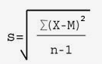

* + With the standard deviation kept in mind, it would be possible to set thresholds to which a majority (68.2%) of employees would fall into. For example, if the employee scored one standard deviation below or less (<2.34) they would automatically be assigned to the training session for that soft skill. If they scored
  + the between one standard deviation below and the average (2.34 - 3.75), training would be highly recommended but would not be automatically assigned. If they the employee scored within the average and one deviation above the average (3.75 - 5.16) they would “meet expectation” and not be signed up for training. Anything above one standard deviation (>5.16) would “exceed expectation” and the employee would not be signed up for training.
  1. Once scores have been assigned to each particular soft skill, a script will query any necessary trainings and send the results in email format to Verve Systems HR. The email will indicate what score each employee received on each soft skill as well as any trainings deemed necessary by the quiz.

1. Project Assumptions

A few assumptions were made in recommending our solutions. They are as follows:-

1. IT Employees will be proficient and able to understand how to access and complete surveys on a web application. This assumption was made as Verve systems is a technology company and IT employees will be able navigate the web application and complete the survey with ease after reading the instructions.
2. Applicability of soft skills- The survey and recommendations for the soft skills we developed will be measured and be more valid towards western soft skills. After consulting Mr. Bawsay and Ms. Dave, we were told that most of their clients are in USA or Europe. Thus, the soft skills will be more applicable to western soft skills.
3. Language - We assumed that the IT employees can speak, read and write in English. Even Though, their might be a slight language barrier with the proficiency of their English skills. It was assumed that they would have a moderate knowledge of the language and would be able to understand basic terms in the survey and the videos.

**Project Roles and Responsibilities**

1. Project Organization Chart:

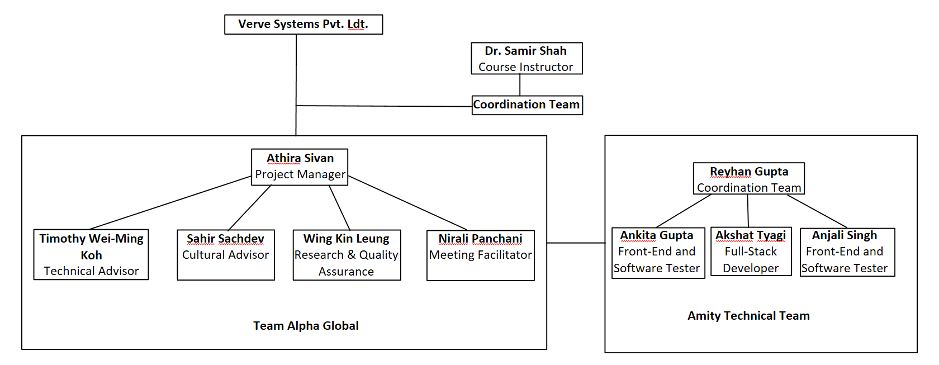

1. Roles and responsibilities of all team Members who worked on this project:

Drexel Team:

* 1. Project Manager - Athira Sivan
     1. Organize meetings, paperwork and communicate with Coordination team
  2. Technical Advisor - Timothy Wei-Ming Koh
     1. Maintaining development standards with technical team in Amity University
  3. Cultural Advisor - Sahir Sachdev
     1. Preventing any miscommunication and misinterpretation with the customer and technical team
  4. Research and Quality Assurance - Wing Kin Leung
     1. Ensure team meeting is in quality compliance for customer
  5. Meeting Facilitator - Nirali Panchani
     1. Documenting meetings and tracking progress of items left to accomplish

Amity Team:

* 1. Full-Stack Developer - Akshat Tyagi
     1. Development on both front-end and back-end. Database creation, server side code and client side code on web application
  2. Front-End and Software Tester - Ankita Gupta
     1. Front-end UI design of web application, testing of software to ensure compliance with Alpha Global standards and data entry into MySQL databases
  3. Front-End and Software Tester - Anjali Singh
     1. Front-end UI design of web application, testing of software to ensure compliance with Alpha Global standards and data entry into MySQL databases

1. Individual Contributions

Drexel Team:

* 1. **Athira Sivan**
     1. Managed team meetings in an effective and efficient manner to ensure all work on Tasks list for the week would be completed
     2. Delegated work to make sure every team member was contributing equally and providing quality outputs.
     3. Acted as main communication liaison between Verve Systems, Amity Tech Team and Coordination team to schedule video conferences, email papers and products, and fix any problems in communication or work during the course of the project.
     4. Compiled all paperwork created by the team in a neat and orderly manner.
     5. Oversaw all activities by Drexel and Amity team
  2. **Timothy Wei-Ming Koh**
     1. Lead Alpha Global to an initial feasibility analysis and high level workflow on the web application
     2. Conveyed technical requirements between Verve Systems and the Amity University team to ensure compliance of the web application
     3. Designed weightage system for questions that would be used to grade employees while taking the quiz
     4. Assisted in researching questions pertaining to delegation and responsiveness
     5. Interviewed Verve Systems employee to gain insight into lacking soft skills and how best they would like to be trained
     6. Maintained meeting log of all meetings that the team held
  3. **Sahir Sachdev**
     1. Assisted in researching questions pertaining to stress handling and communication.
     2. Conducted interviews with Verve systems employees. Due to the language barrier, conducted them in Hindi.
     3. Assisted in researching videos for all the 5 categories of soft skills.
     4. Prevented any miscommunication with the technical teams and customer. Translated any jargon, corrected misinterpretations.
     5. Attended video conferences with the client and the team at Amity University to discuss the project.
  4. **Wing Kin Leung**
     1. Assisted in researching questions pertaining to communication and grooming.
     2. Assisted in researching videos for communication and grooming
     3. Provided suggestions for the class projects to help the team run smoothly.
     4. Organized the work cited/references and made sure all the videos were working.
     5. Counted the messages from beginning between the team (Alpha Global) and Amity technical team in India.
  5. **Nirali Panchani**
     1. Helped to develop the requirements for the project and contributed to the completion of all deliverables.
     2. Attended video conferences with the client and the team at Amity University to discuss the project.
     3. Responsible for downloading the needed software and providing a demo of web application to the client. Also was responsible for creating
     4. instructions manual for client on downloading and testing the web application.
     5. Created the meeting minutes for the team
     6. Assisted in the research of the initial survey questions pertaining to grooming and delegation
     7. Conducted an interview through video conference with an employee at Verve Systems to inquire more about their soft skills knowledge and training

Amity Team:

* 1. **Akshat Tyagi**
     1. Responsible for back end development for database design.
     2. Design of the modules and functionalities of the application
     3. Ensured relevant front end design as requested by Drexel Team
     4. Responsible for the jquery functionality of all the modules and bootstrap framework configuration of the pages etc.
  2. **Ankita Gupta**
     1. Researched and developed the front end design for the home page
     2. Provided relevant content to be added to the homepage based on feedback from Drexel Team
     3. Tested the overall build of the application for quality assurance
  3. **Anjali Singh**
     1. Maintained data integrity of SQL tables
     2. Tested the Quiz, Scorecard and Authentication module to ensure that data was properly stored in SQL tables
     3. Tested the overall build of the application for quality assurance

**Team Member Hour Log**

* **Athira Sivan**: Wk82hr
  + Week 2 (Monday 27th June to Sunday July 3rd):
    - 1 hr, 30 mins
  + Week 3: (Monday 4th July to Sunday July 10th)
    - 4 hrs
  + Week 4: (Monday 11th July to Sunday 17th July)
    - 3 hrs, 15 mins
  + Week 5: (Monday 18th July to Sunday 24th July)
    - 6 hrs, 30 mins
  + Week 6: (Monday 25th July to Sunday 31st July)
    - 6 hrs 15 mins
  + Week 7: (Monday 1st August to Sunday 7th August)
    - 3hrs
  + Week 8: (Monday 8th August to Sunday 14th August)
    - 9hrs 20 mins
  + Week 9: (Monday 15th August to Tuesday 16th August)
    - 4hrs 30min
* **Timothy Wei-Ming Koh**
  + Week 2 (Monday 27th June to Sunday July 3rd):
    - 1 hr, 17 mins
  + Week 3: (Monday 4th July to Sunday July 10th)
    - 3 hrs, 51 mins
  + Week 4: (Monday 11th July to Sunday 17th July)
    - 3 hrs, 3 mins
  + Week 5: (Monday 18th July to Sunday 24th July)
    - 6 hrs, 5 mins
  + Week 6: (Monday 25th July to Sunday 31st July)
    - 5 hrs, 55 mins
  + Week 7: (Monday 1st August to Sunday 7th August)
    - 3 hrs
  + Week 8: (Monday 8th August to Sunday 14th August)
    - 6 hrs 50 min
  + Week 9: (Monday 15th August to Tuesday 16th August)
    - 4 hrs
* **Nirali Panchani**
  + Week 2 (Monday 27th June to Sunday July 3rd):
    - 1 hr, 17 mins
  + Week 3: (Monday 4th July to Sunday July 10th)
    - 3 hrs, 51 mins
  + Week 4: (Monday 11th July to Sunday 17th July)
    - 3 hrs, 3 mins
  + Week 5: (Monday 18th July to Sunday 24th July)
    - 6 hrs, 15 mins
  + Week 6: (Monday 25th July to Sunday 31st July)
    - 5 hrs, 55 mins
  + Week 7: (Monday 1st August to Sunday 7th August)
    - 3 hrs, 15 mins
  + Week 8: (Monday 8th August to Sunday 14th August)
    - 6 hrs 45 mins
  + Week 9: (Monday 15th August to Tuesday 16th August)
    - 4 hours
* **Sahir Sachdev**
  + Week 2 (Monday 27th June to Sunday July 3rd):
    - 1 hr, 17 mins
  + Week 3: (Monday 4th July to Sunday July 10th)
    - 3 hrs, 51 mins
  + Week 4: (Monday 11th July to Sunday 17th July)
    - 3 hrs, 3 mins
  + Week 5: (Monday 18th July to Sunday 24th July)
    - 6 hrs, 5 mins
  + Week 6: (Monday 25th July to Sunday 31st July)
    - 5 hrs, 25 mins
  + Week 7: (Monday 1st August to Sunday 7th August)
    - 2 hrs, 30 mins
  + Week 8: (Monday 8th August to Sunday 14th August)
    - 7 hrs, thus far
  + Week 9: (Monday 15th August to Tuesday 16th August)
    - 1hr
* **Wing Kin Leung**
  + Week 2 (Monday 27th June to Sunday July 3rd):
    - 1 hr, 17 mins
  + Week 3: (Monday 4th July to Sunday July 10th)
    - 3 hrs, 51 mins
  + Week 4: (Monday 11th July to Sunday 17th July)
    - 3 hrs, 3 mins
  + Week 5: (Monday 18th July to Sunday 24th July)
    - 6 hrs, 5 mins
  + Week 6: (Monday 25th July to Sunday 31st July)
    - 5 hrs, 25 mins
  + Week 7: (Monday 1st August to Sunday 7th August)
    - 2 hrs, 30 mins
  + Week 8: (Monday 8th August to Sunday 14th August)
    - 6 hrs, 20 mins, thus far
  + Week 9: (Monday 15th August to Tuesday 16th August)
    - 4 hrs

**Group Communication**

1. Number of email exchanges between you and your customer **122**
2. Number of email exchanges between you and your technical/in-country team in India **19**
3. Number of email exchanges within your team **32**
4. Number of video conferencing sessions with your customer: **7**
5. Number of video conferencing sessions between you and your technical/in-country India team: **4**
6. Number of text messages sent among your team members: **794**
7. Number of text messages sent among you to your Tech Team: **279**
8. Total Number of Questions/Clarifications asked between you and your customer **20**
9. Total Number of Questions/Clarifications asked between you and your technical/in-country team in India **5**

**Tools and Techniques**

* Tools:
  + Weekly Meetings: This was the main source of productivity, idea sharing and planning for the rest of the week. Having a set, concrete time every week allowed

us to have a non-arbitrary deadline for all work assigned. It was agreed at the beginning of the term by all members of our team that we worked best when

working face to face. This maximized the amount of work we could do in lieu of tight schedules.

* + Zoom: Our team utilized Zoom for the majority of all video conferences with Verve Systems and all video conferences with our Amity tech team. Zoom is a professional video conferencing application that allowed us to easily have multi-person video conferences and record them for reference as we continued with our project. It was also easy to ‘share screen’ on Zoom in order to let whoever we were video conferencing with see what applications were running on our computer without them having to download and run the program; this is how we worked with Amity as they created the survey and how we showed Mr. Bawsay what we had created.
  + Skype: Skype was a backup video conferencing application we utilized in the instance where Zoom was not working properly. We made sure we had a backup option to ensure there would be minimal time delays if there were any technical problems when setting up a video conference. Skype was used only once during a one-on-one interview between our team members and a Verve Systems employee.
  + Whatsapp: This chat application was the second largest source of productivity and largest source of communication. There was one chat made exclusively for Alpha Global members and another chat made for Alpha Global and the Amity Team. Whatsapp made it easy to reach out to any member of the team, ask questions as you were doing the work assigned for the week, and to have a steady stream of conversation that allowed members to bond and become close to each other.
  + Email: Drexel and Gmail were the main source of communication with Verve Systems CEO Nitin Bawsay, HR Head Purvi Dave and Coordination team. All emails were formatted in a formal and professional manner. Emails made it easier to work with Verve Systems around the major time zone difference all project members faced. This is the main form of communication used when sending documents (ie the Initial project plan, Verve Systems Soft Skills Survey, Interview dates and times) and scheduling video conference dates and times. Email was also used with the Amity Team where they would send us the survey application and a team member would download it so we could work with it and make minor changes.
* Techniques:
  + Communication: Constant communication was key in making sure there were no misunderstandings or unanswered questions as the project progressed. Towards Verve, our team made sure we consistently emailed them before and after each scheduled video conference to make sure the meeting was still scheduled and to follow up on any questions they may have afterwards. Another major

communication point with Verve was sending weekly updates every Friday to let

Mr. Bawsay know how much we had finished and how much there was left to do.

For communication with the the Amity Team we set up a Whatsapp group. This

chat allowed them to

ask us any questions or provide comments on the work they were doing so far.

Within the team internally we also utilized Whatsapp to talk to each other

throughout the week and this in addition to weekly meetings contributed to

maximum productivity and avoidance of confusion.

* + Timeline: Having a timeline created that spanned from Week 2-Week 10 let the team stay on track. Each Week had assigned work that needed to be completed (in the form of a “To Do” list). As each assignment was finished, it would be crossed off the list. This allowed us to keep the bigger picture in mind as the project continued rather than get caught up in small, time consuming details that would end up costing valuable time. Seeing our achievements thus far as the project continued was also a boost in moral. Knowing we have the ability to cross off all things on every weeks’ To Do list was a boost in confidence in our ability to complete the project in a timely manner and also present a product that was high standard.
  + Deadlines: Creating strict deadlines for all assigned work kept the project on track and keep up with the timeline. Deadlines were given internally on when ideas needed to be fully fleshed out to present to Verve and to give to Amity for them to produce. Additionally, internal deadlines were given in regards to the employee survey and interviews we had to make sure it wasn’t too time consuming and the project could continue with those two vital sources of information. Having deadlines in regards to contact with Verve and production of products with the company allowed us to be professional and appear capable when continuing with the project. Once we understood the skill set available to us through our Amity Tech Team we discussed and came up with appropriate deadlines for when we wanted them to give us a product each week. The structure provided by having deadlines made it more simple when doing work because knowing there is a hard deadline made teams more productive and efficient.
  + Research: When deciding which five skills to focus on we researched renowned workplace activity sites and workplace behaviour papers and articles. We also took input from Mr. Bawsay and information from last term’s teams. After deciding the five skills we researched subtopics in the skills that we could format into survey style questions in order compress them into an efficient format to send to Verve System employees. For our survey module we searched for workplace habit videos and tutorials that we could use as a result for employees that need training.
  + Interviews: We had 5 one on one interviews with Verve employees as an information gathering technique. We chose these employees from the results we received from the initial survey we had sent out. The reasoning for the interviews following the survey was to gather even more in depth knowledge about the employee’s skills in regards to soft skills. We chose 5 employees in total in deference to their busy work schedules and time zone differences.
  + Survey: We used an initial survey sent out to all Verve Systems employees as a method for ratifying the 5 skills we had chosen to focus on. Of the 48 employees who took the survey we got 45 viable responses back. The survey allowed us to see we were on the right track and how we could tailor our final project product to meet the needs the employees displayed through the survey.

**Appendix**

* Appendix A - Initial Survey

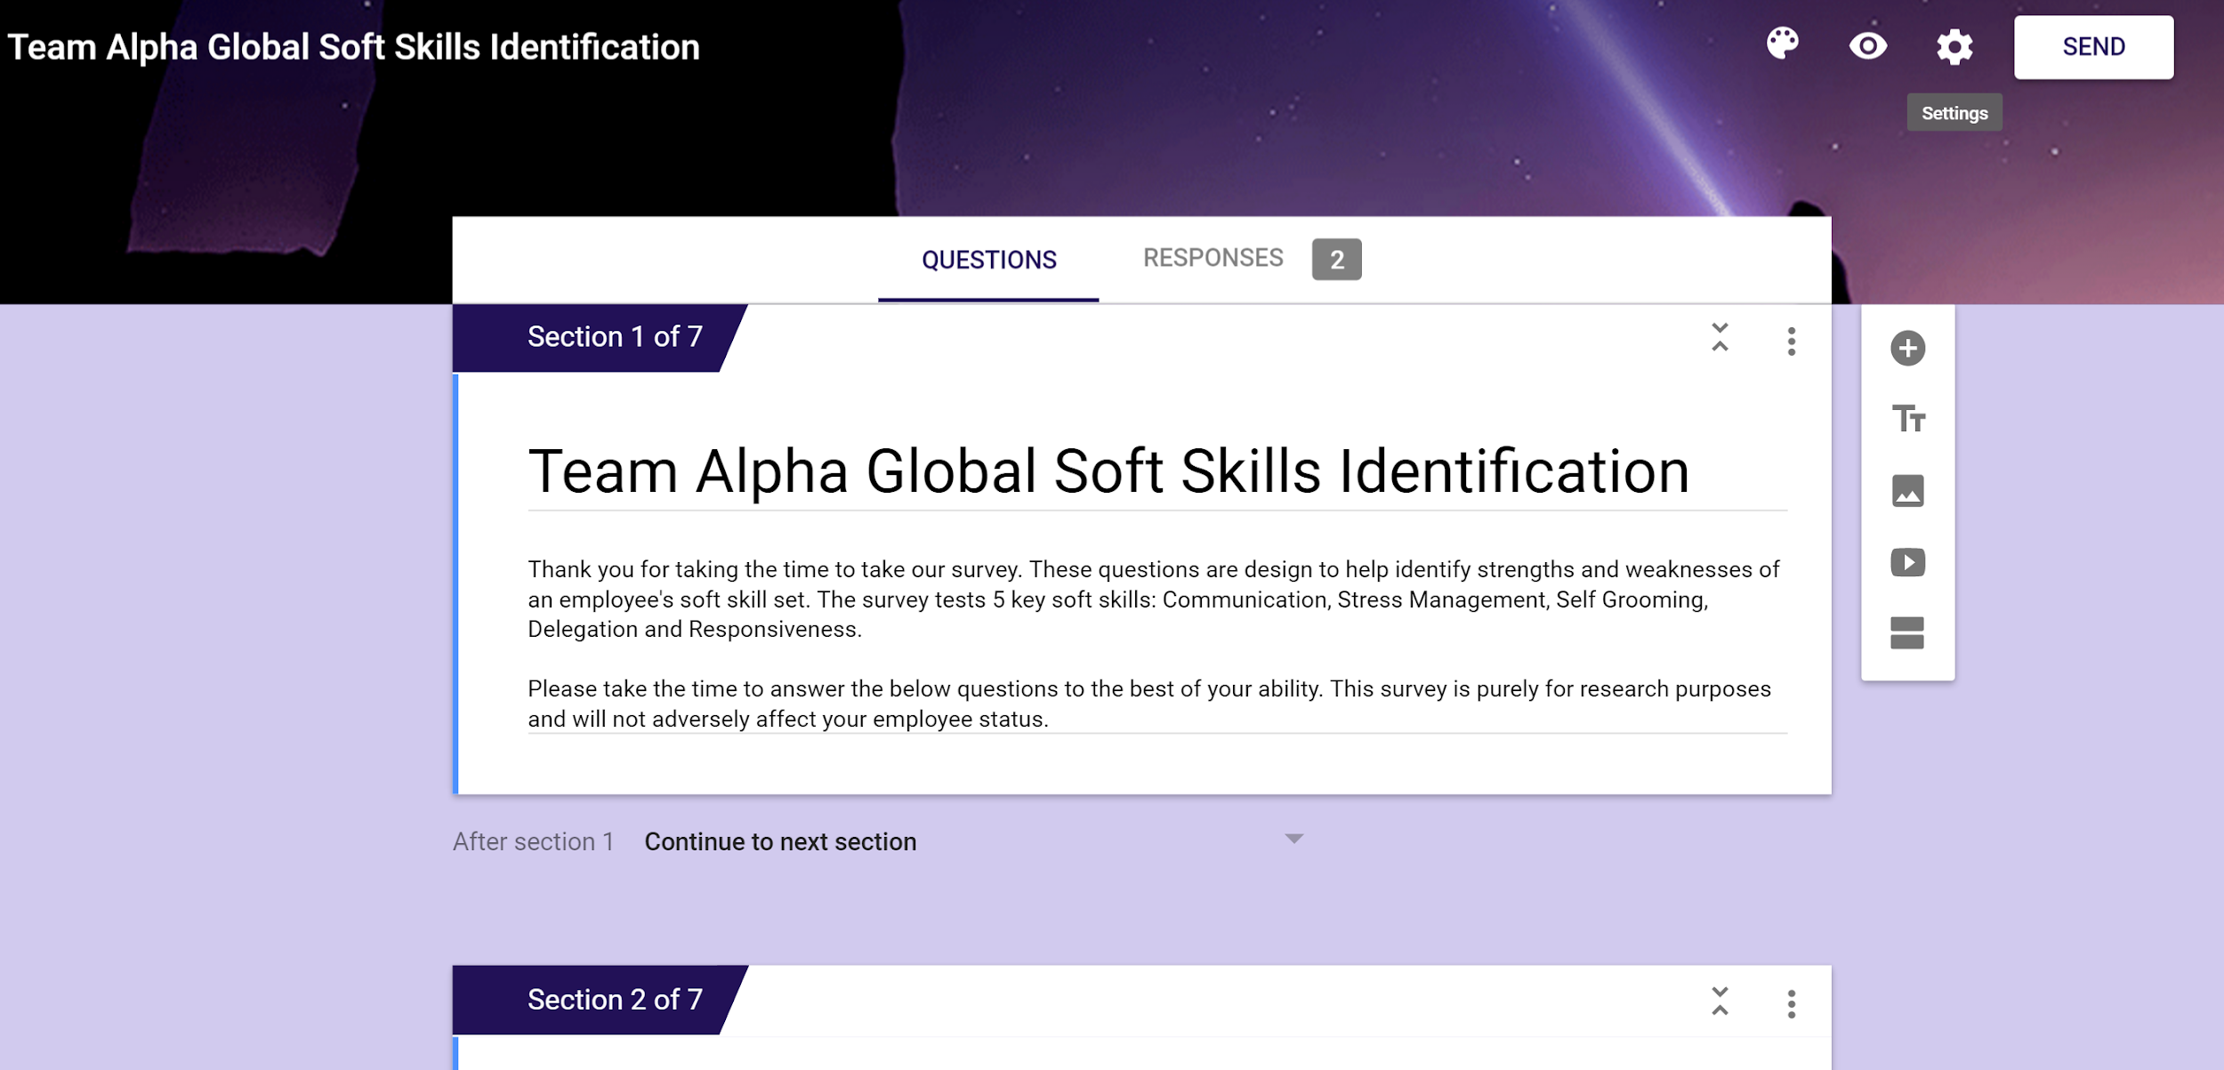

* Appendix B - Initial Survey Results

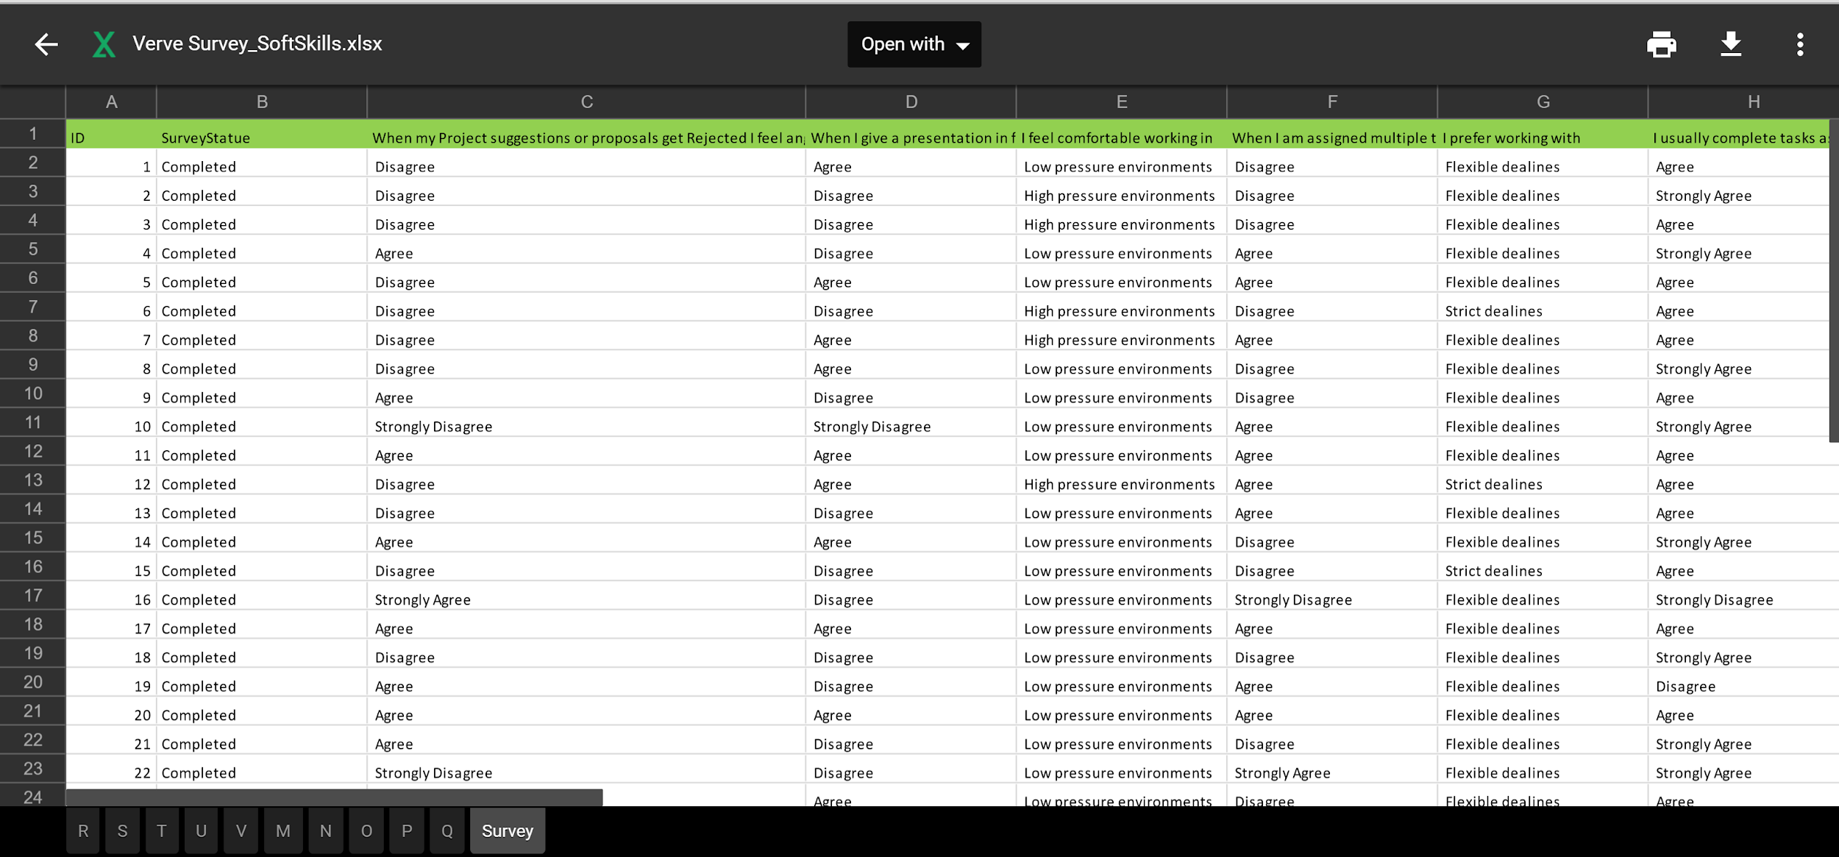

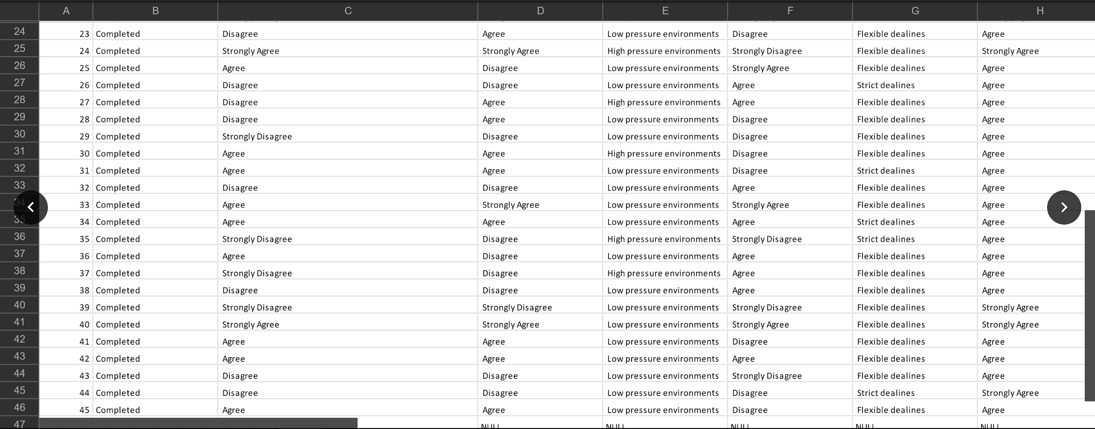

* Appendix C - Survey Analysis

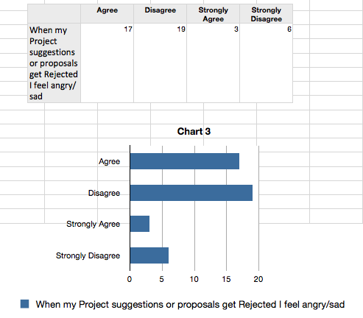

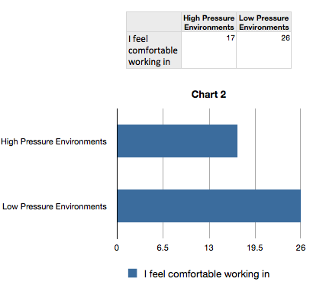

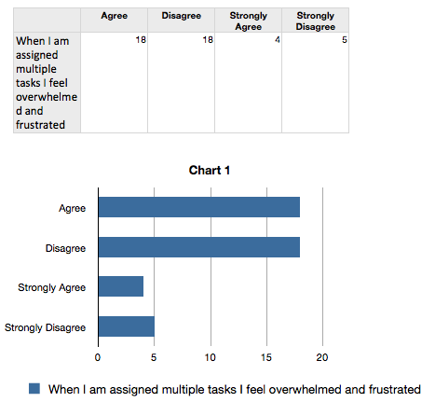

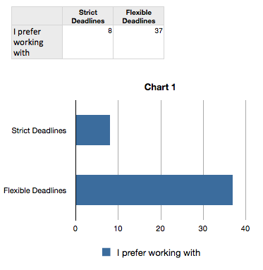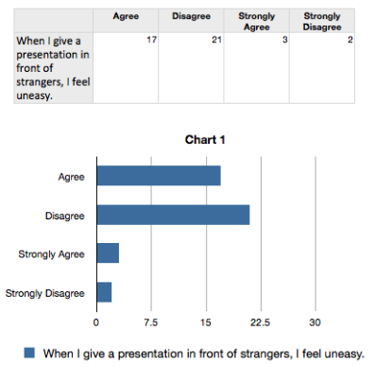

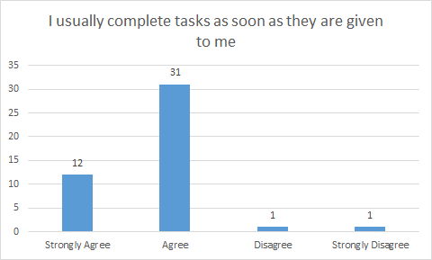

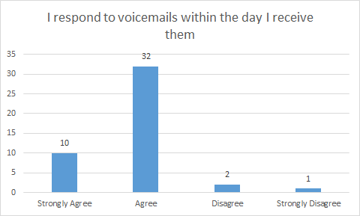

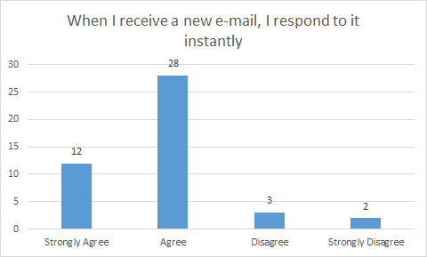

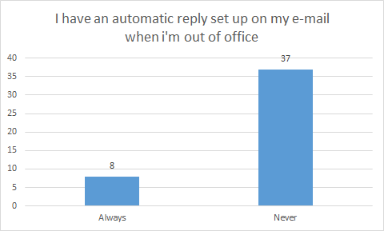

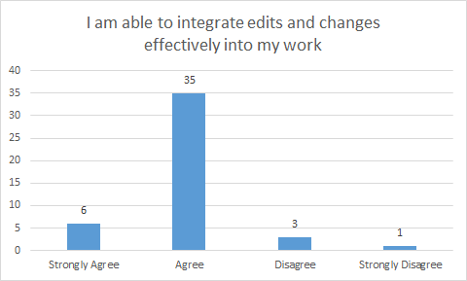

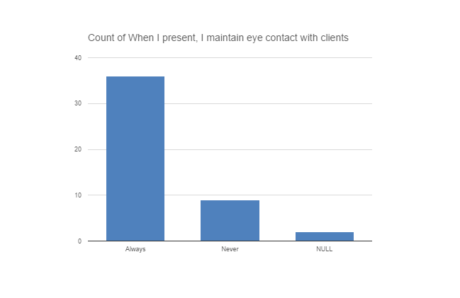

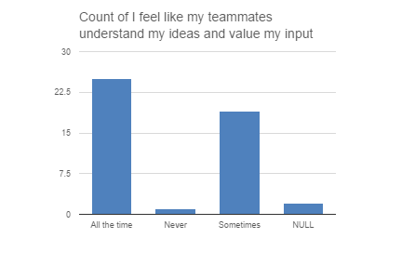

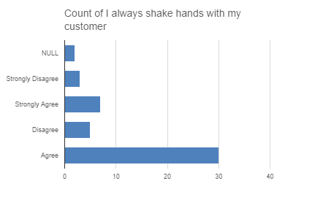

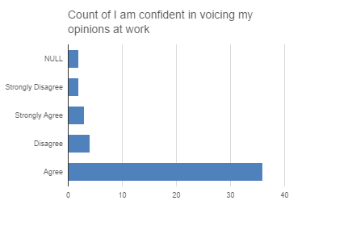

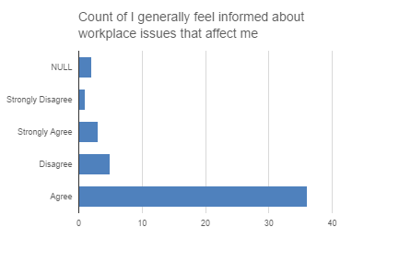

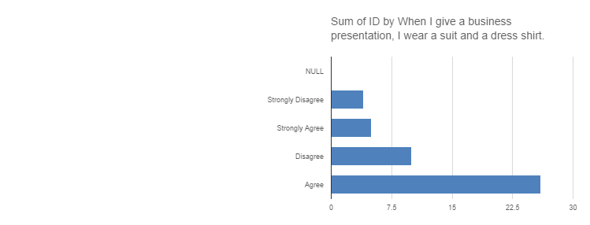

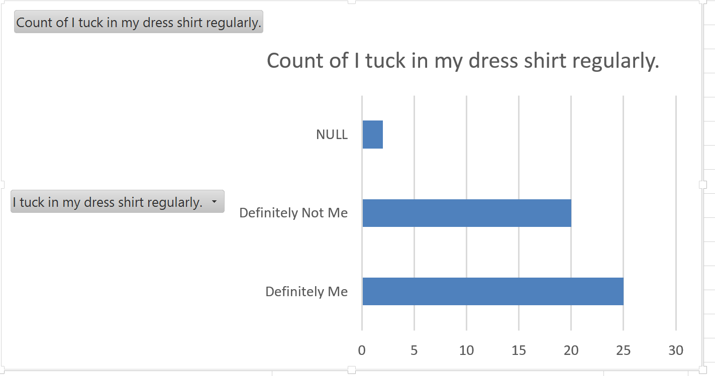

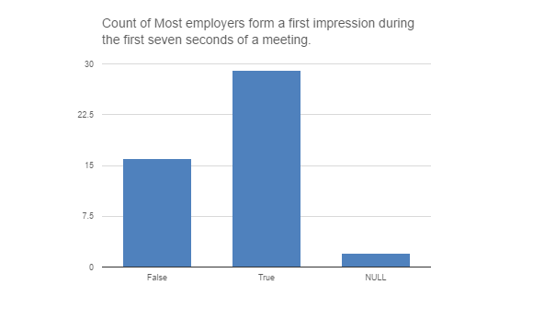

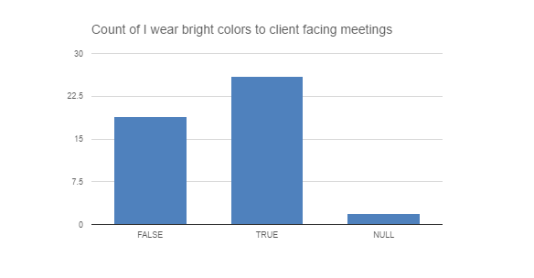

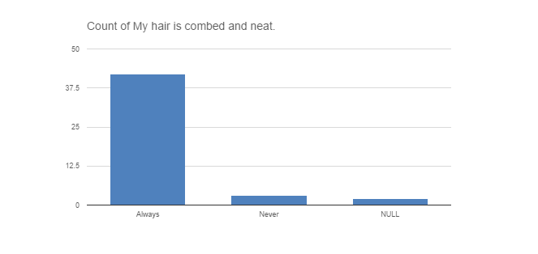

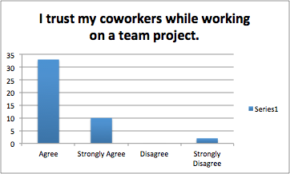

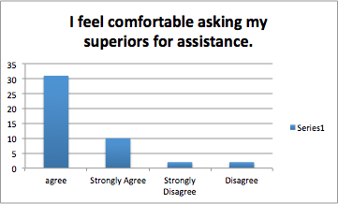

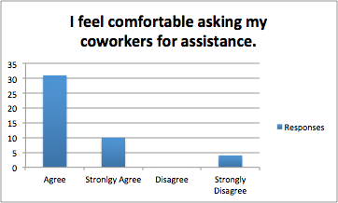

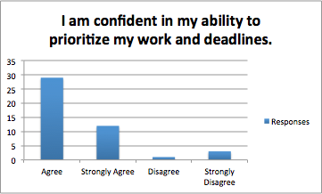

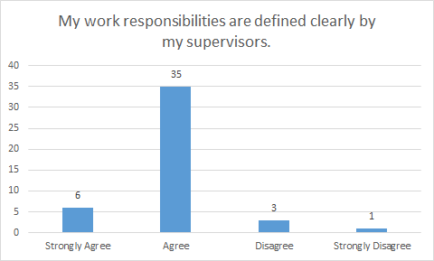

* Appendix D - Point System Creation

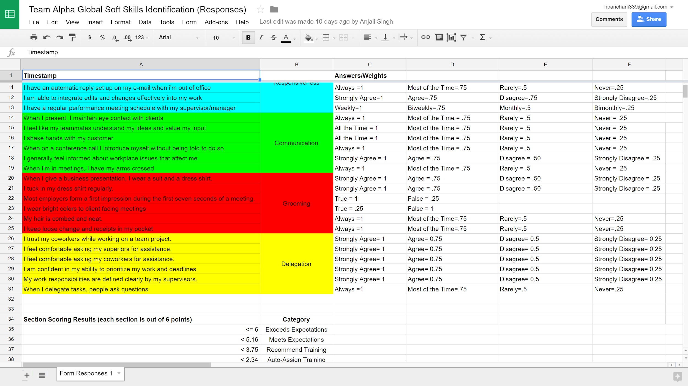

* Appendix E - Approval by CEO of Latest Project Plan and thus entire project

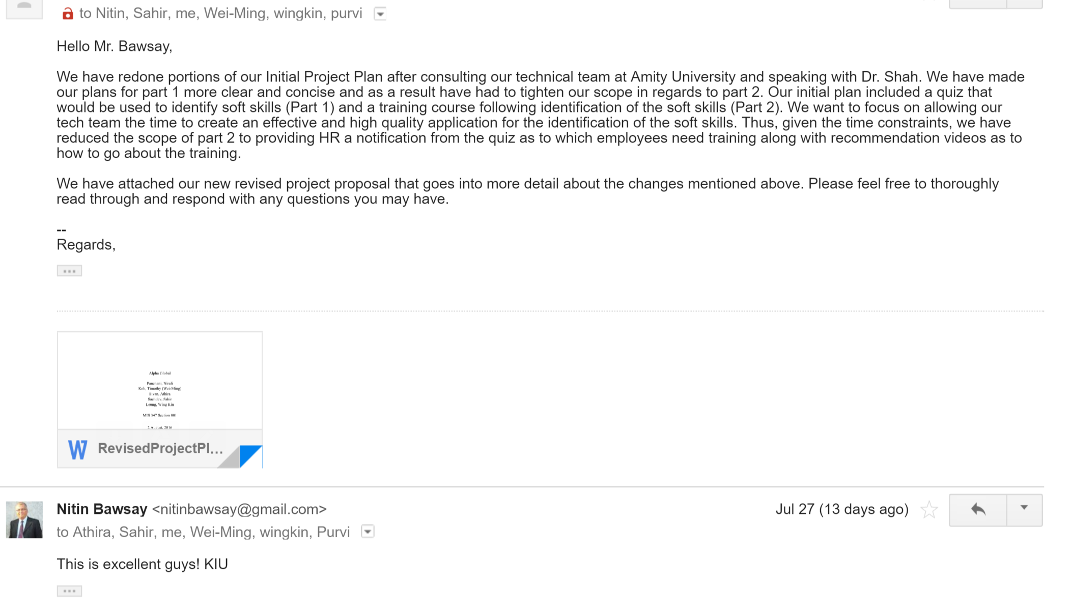

* Appendix F - Web Application Database

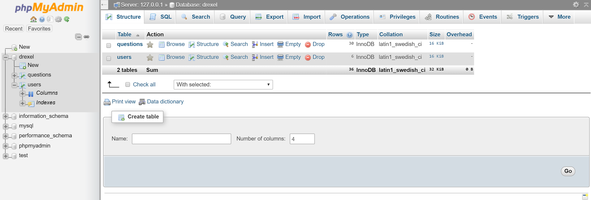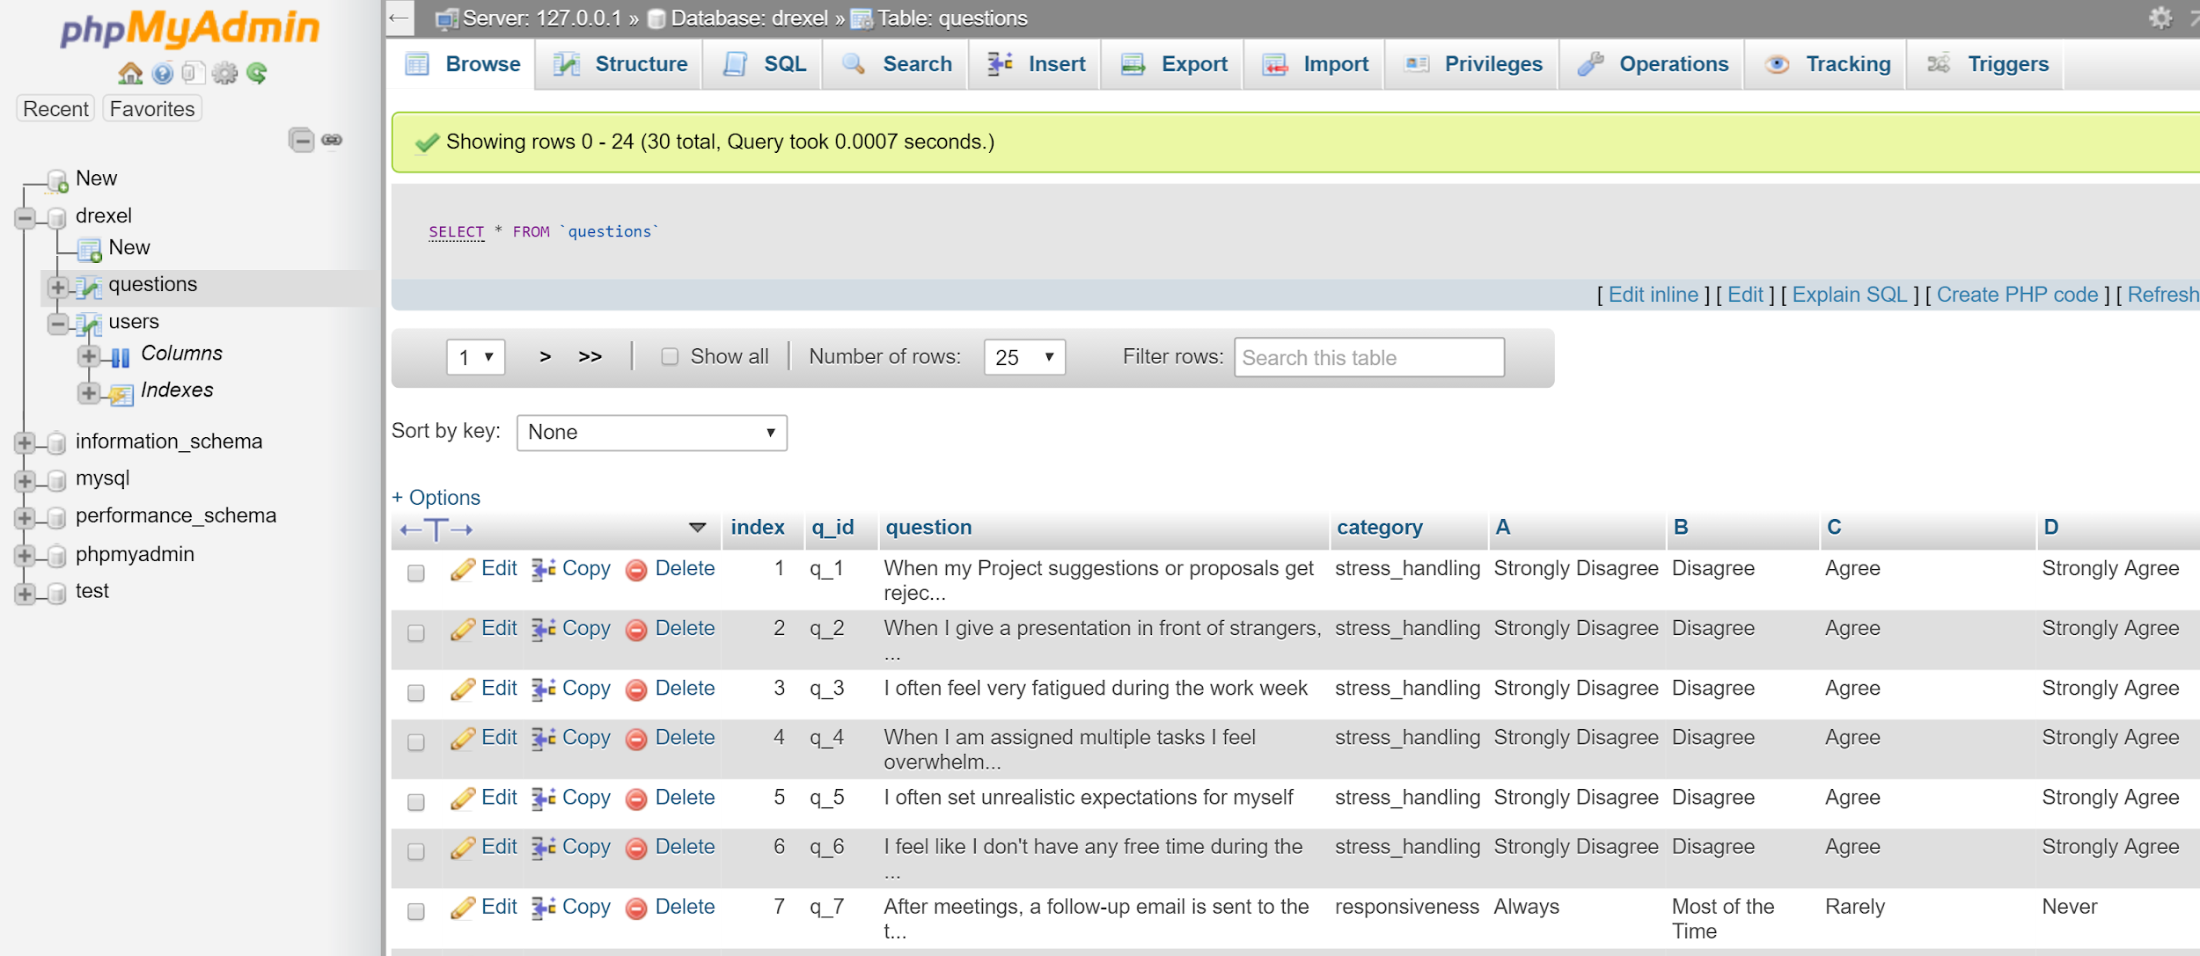

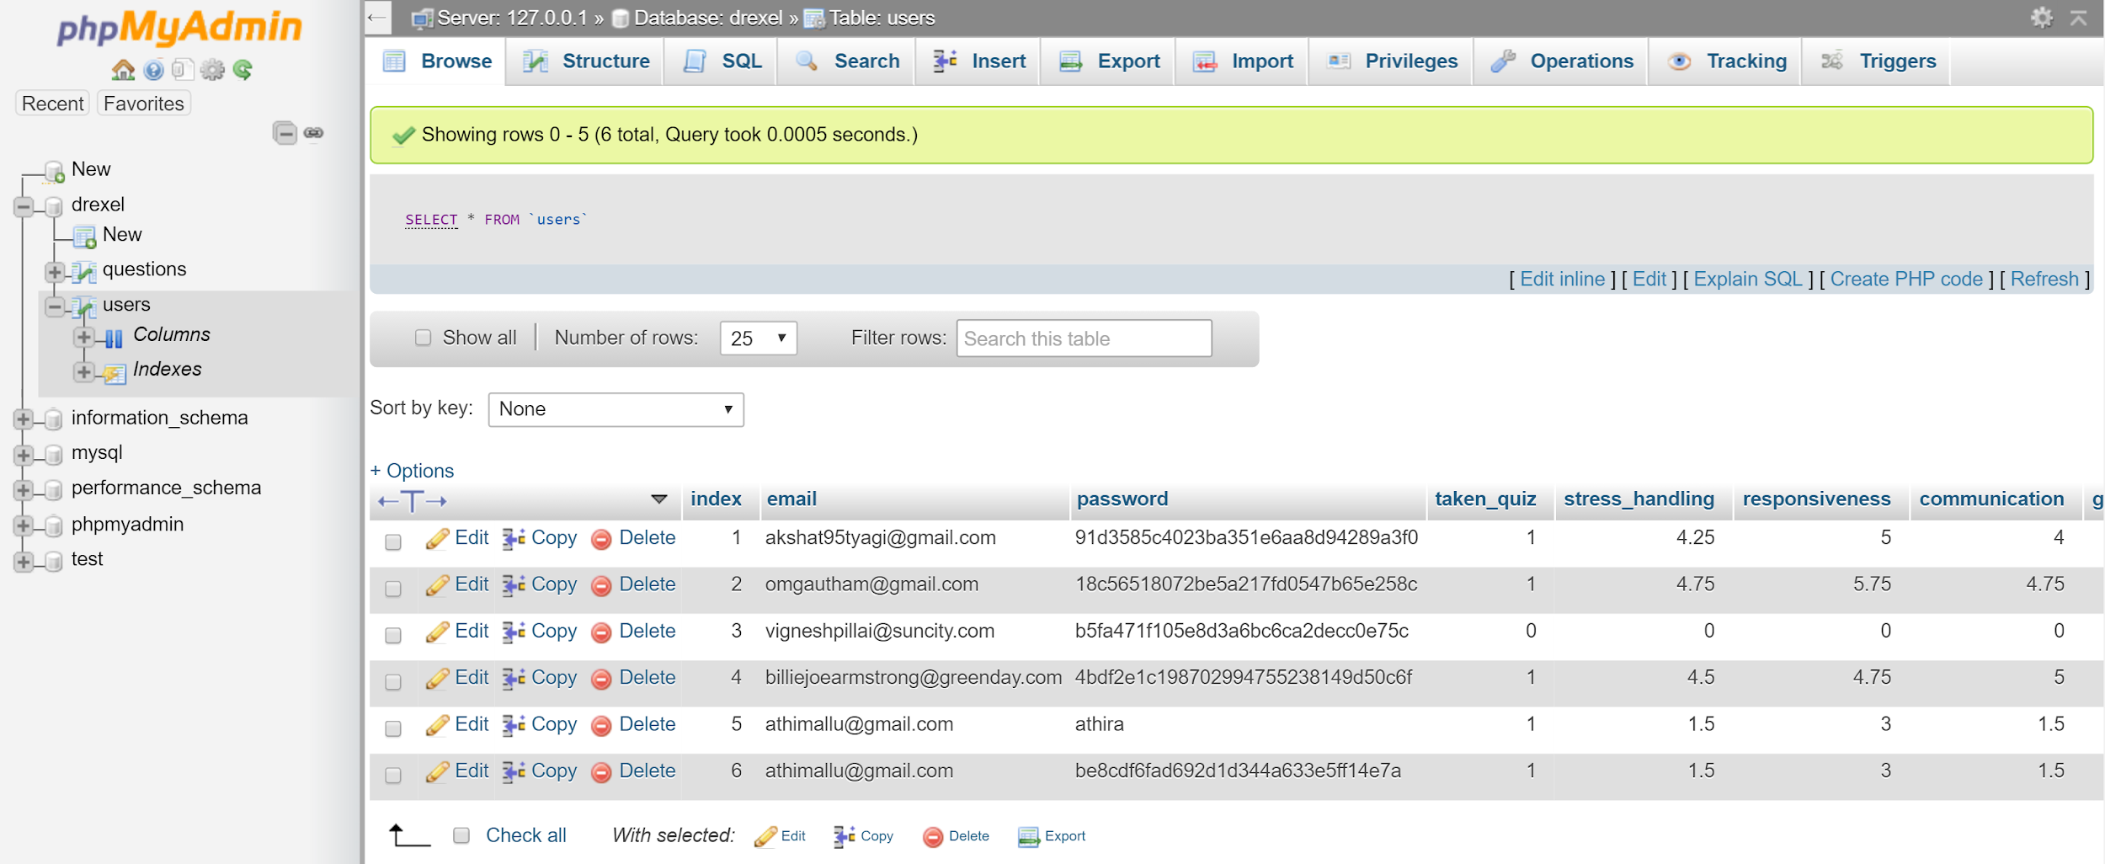

* Appendix G - Instructions for downloading and accessing

**Instructions for accessing web application:**

1. Download XAMPP at: <https://www.apachefriends.org/download.html>. The most recent version is 7.0.8. Please download the version most compatible with your system.

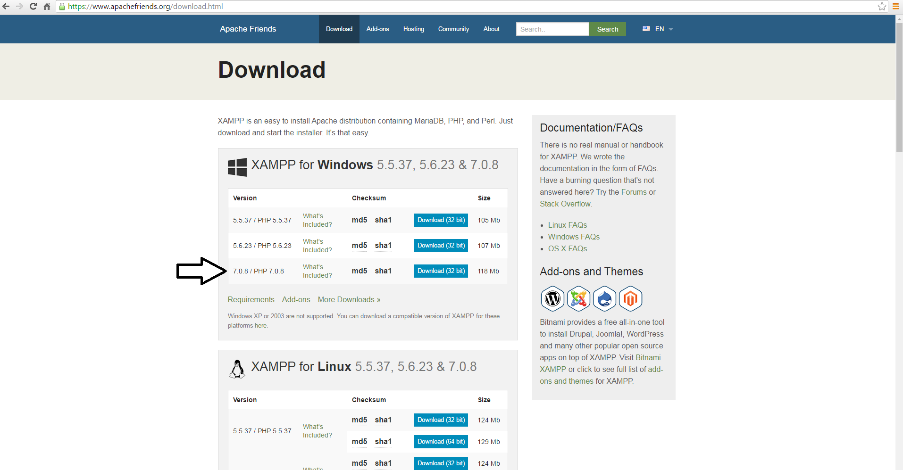

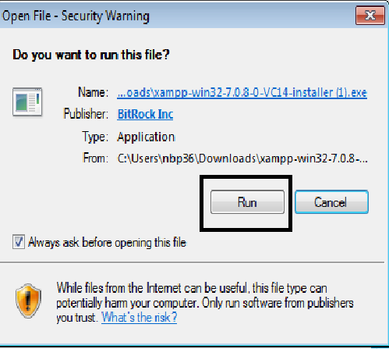

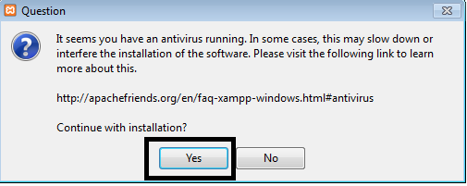

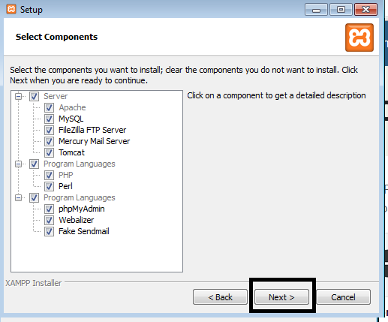

When you get to the following screen, uncheck the box if you desire and hit next: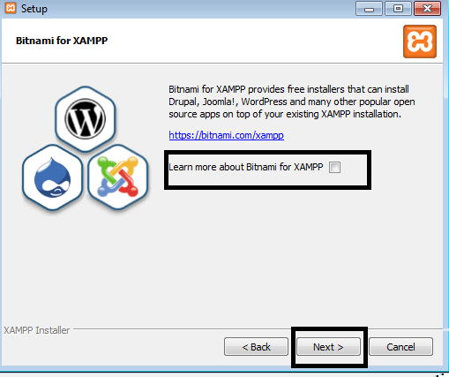

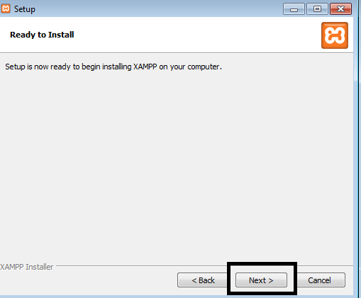

The installation will begin. At the end the following screen will show: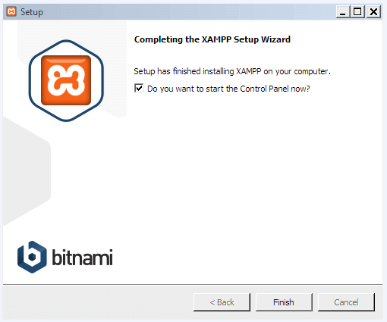

Hit Finish. XAMPP is now downloaded. Ensure that the xampp folder is in the local (:C) drive.

2. In the XAMPP Control panel, hit “Start” for Apache and MySQL. IMPORTANT: If you are unable to start Apache and MySQL, force close it and then attempt it again: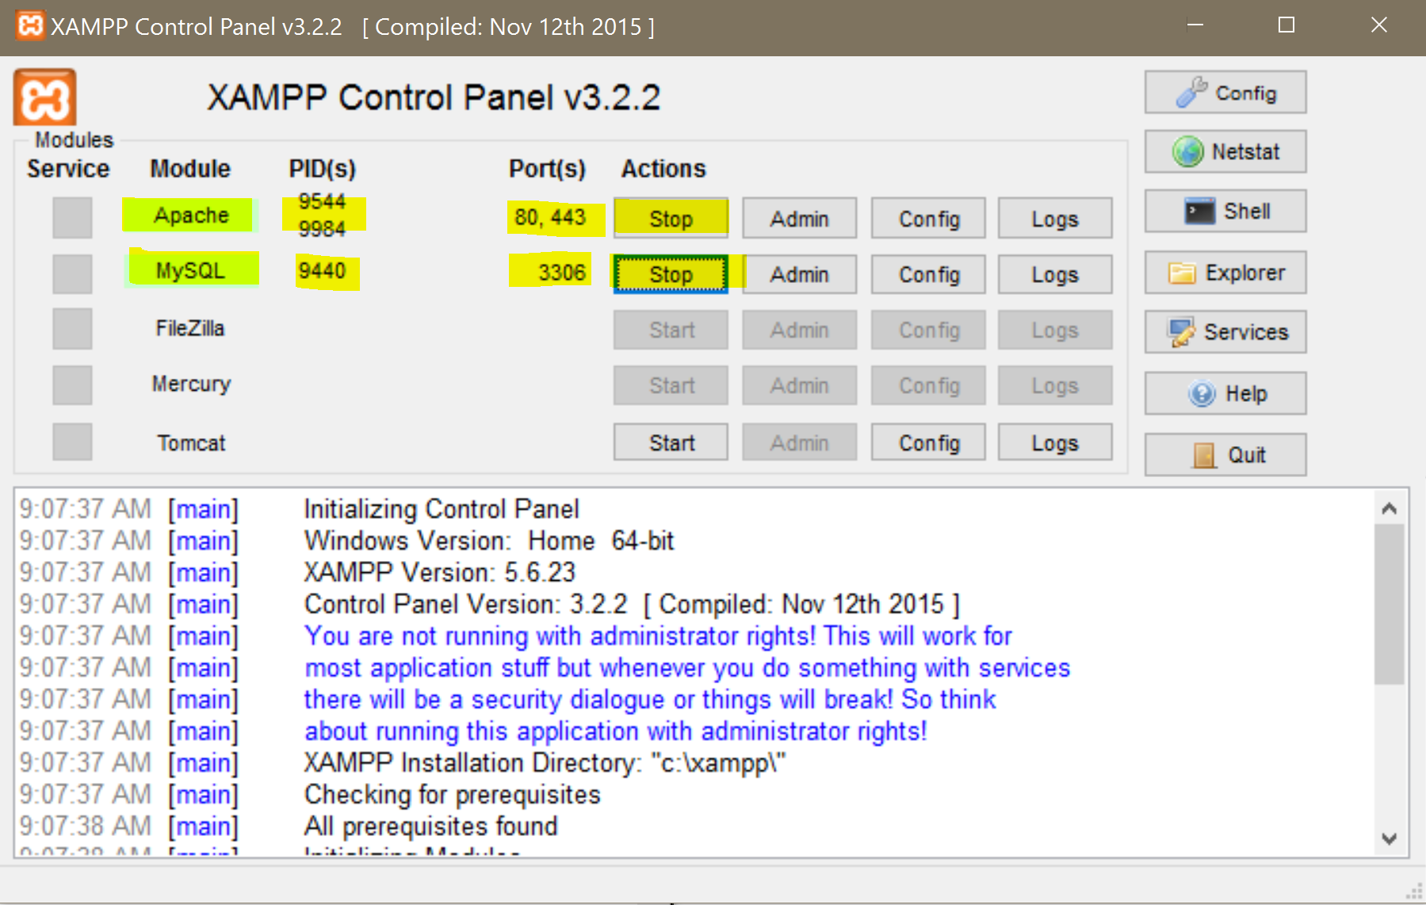

3. Download the drexel.sql file provided through email. You will need this file later.

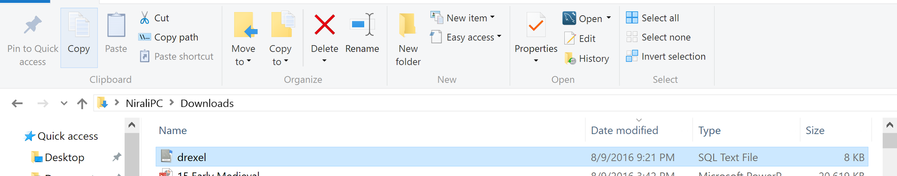

4. Download the Drexel.7z file provided through email. You will need this file later.

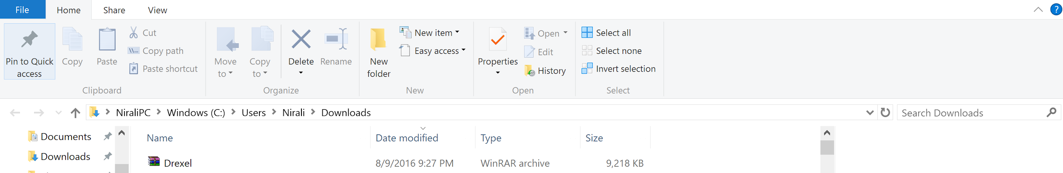

5. Type “localhost/phpmyadmin/” into the browser.

6. Create new Database labeled “drexel”. The new button can be found in the left bar under the Recent and Favorites buttons:

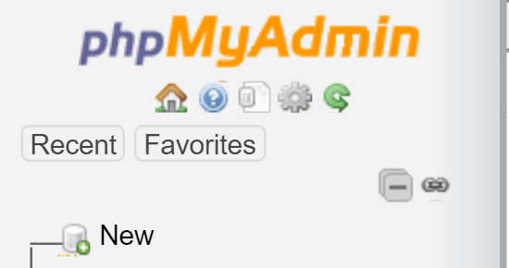

After you press new, there should be an area to create a database on the right. Fill in ‘drexel’ as the name. Keep Collation. Click on create:

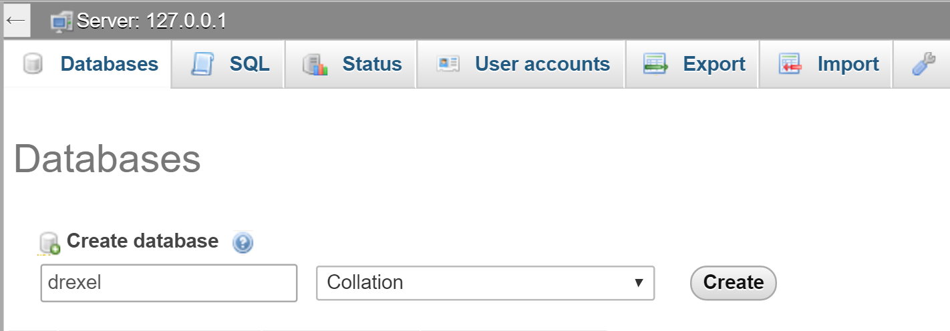

7. Make sure the drexel database is highlighted:

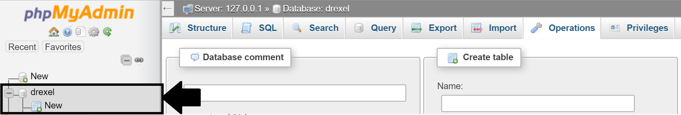

8. Click Import tab. After clicking, the screen should be as follows:

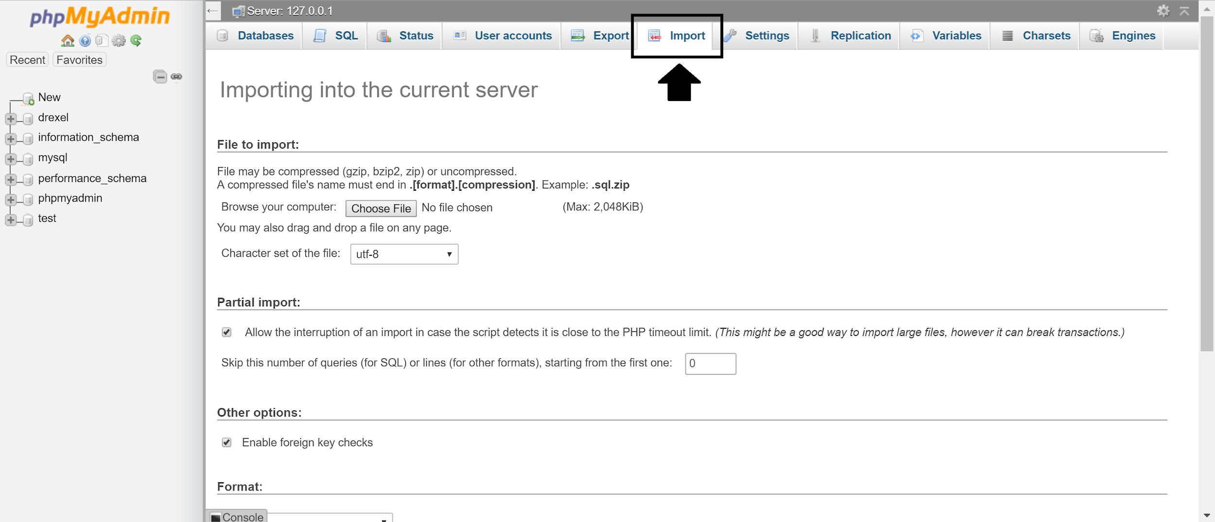

9. Click on the ‘Choose File’ button and select the drexel.sql file. Scroll to the bottom of the page and hit “Go”:

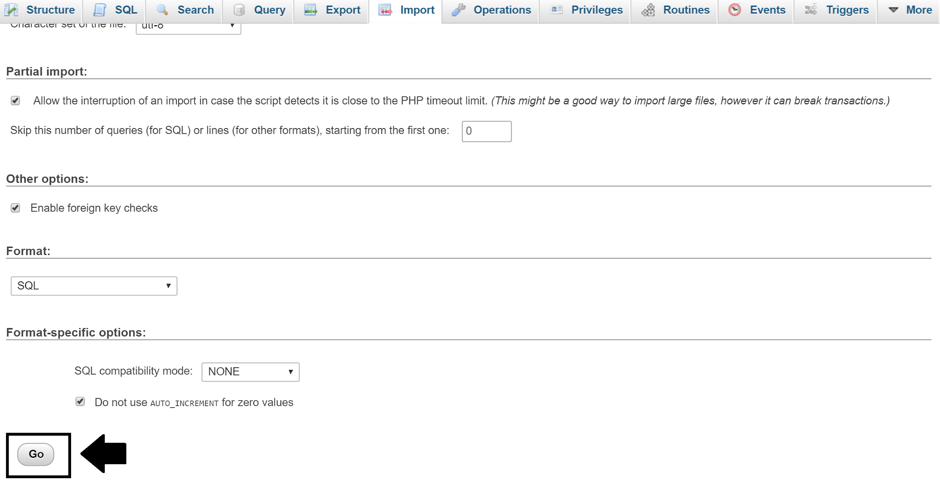

10. Extract the Drexel folder from the Drexel.7 file into the htdocs folder. Utilizing WinRAR would be the best way to do this. If you do not have WinRAR please utilize the following link: <http://www.winzip.com/lan7z.htm> :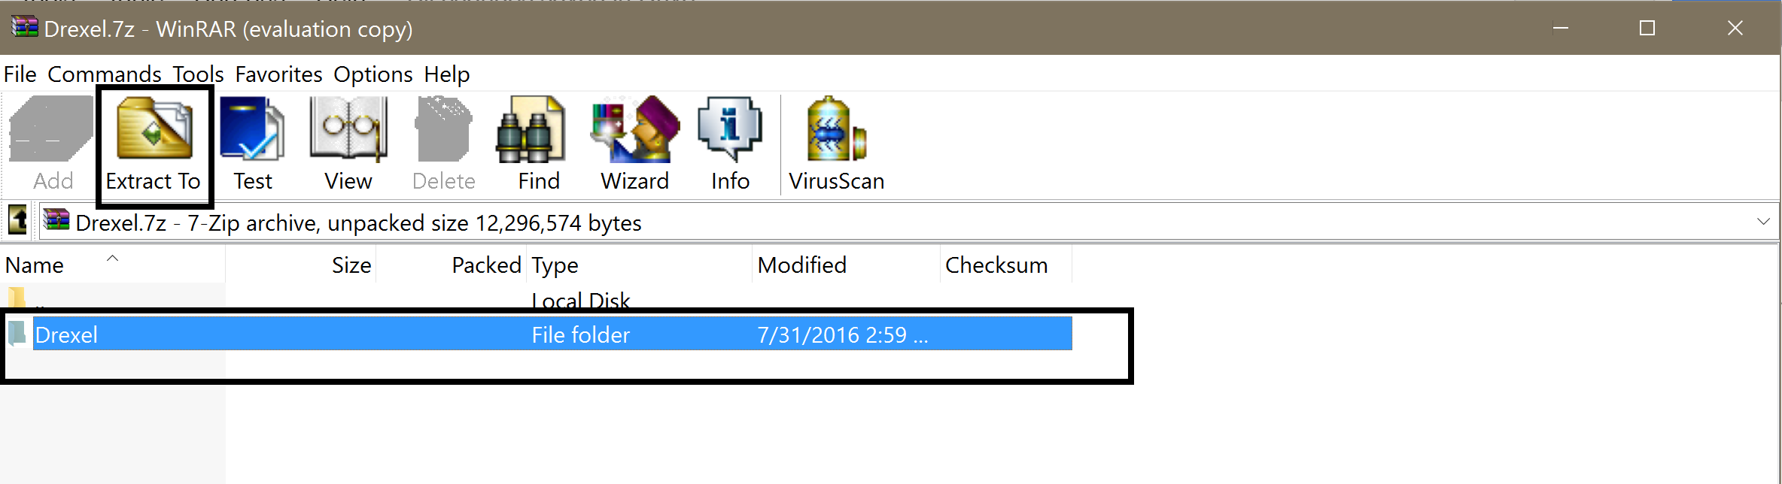

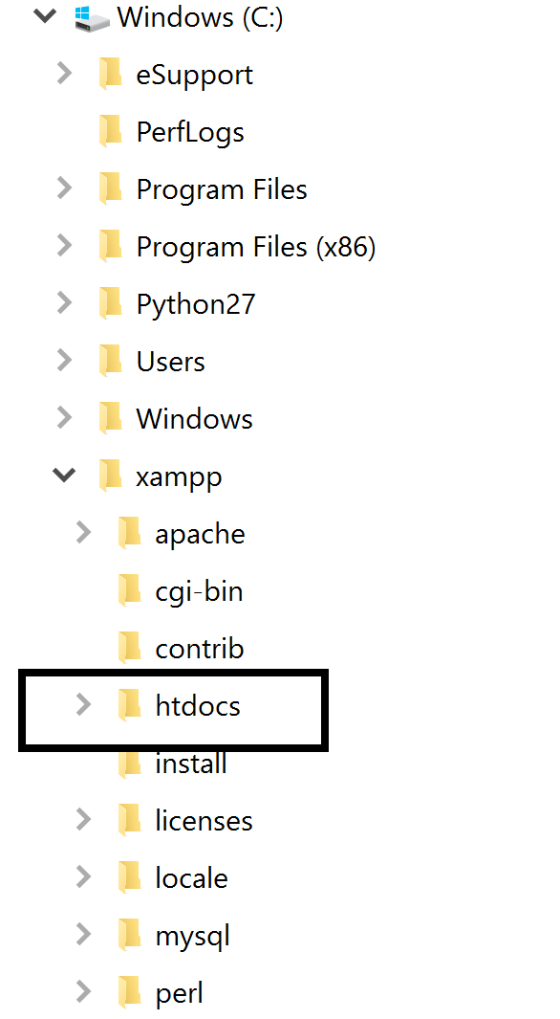

11. In your browser type “<http://localhost/Drexel/>” The screen should be as follows:



12. Click on Get Started:



13. Click on proceed here, fill out appropriate information, and press begin:

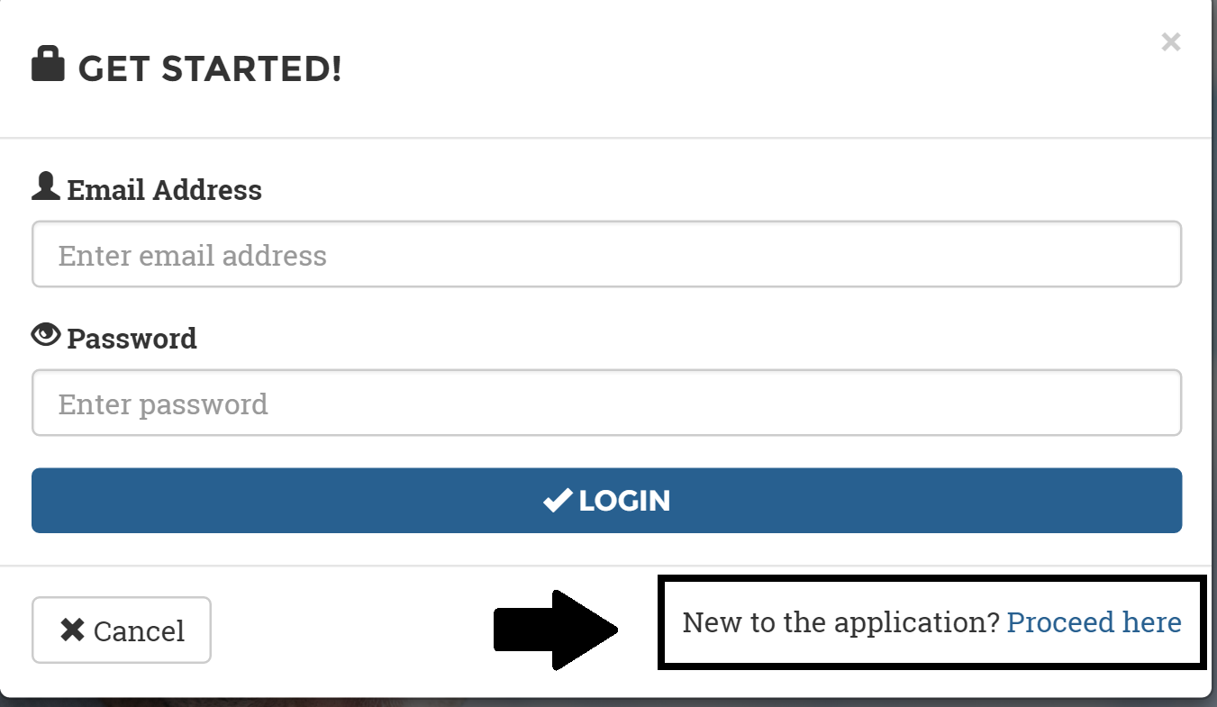

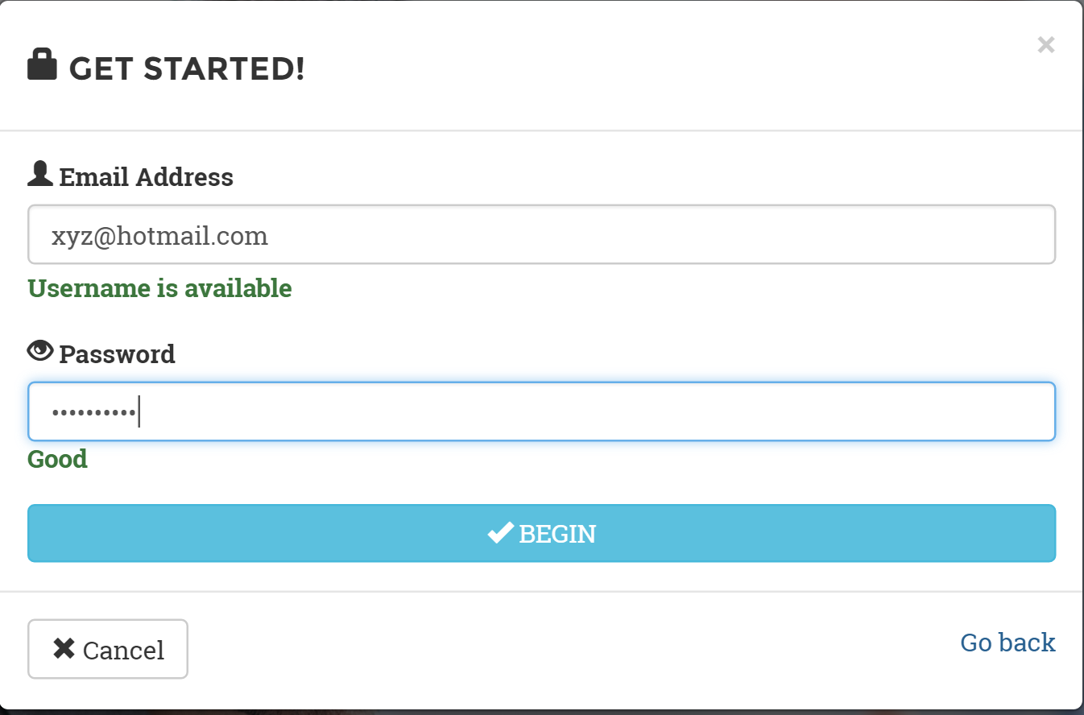

You may be shown a dialog box. Just hit ok:

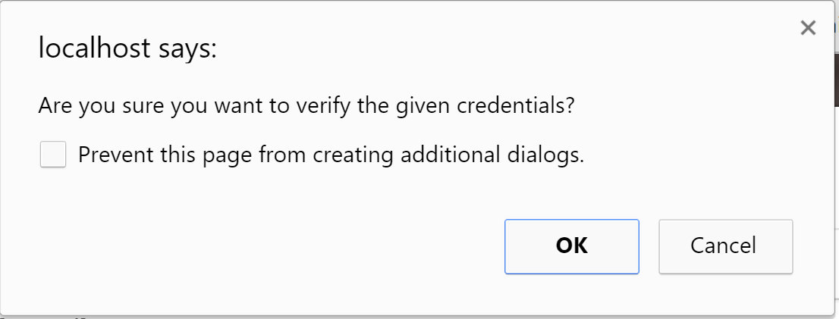

14. The page will take you back to the main login page. Hit Login.

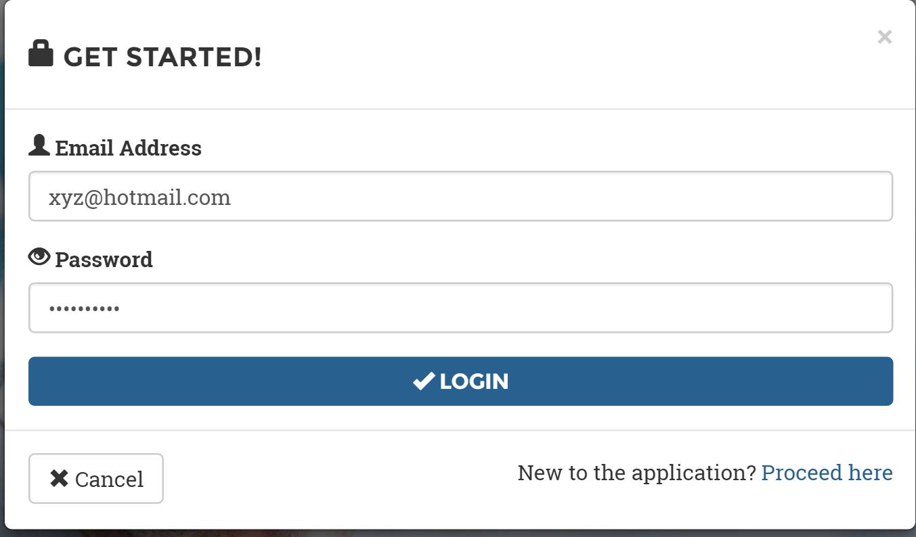

15. You will be taken to the Instructions page. Scroll to the bottom and click “Start the Quiz”

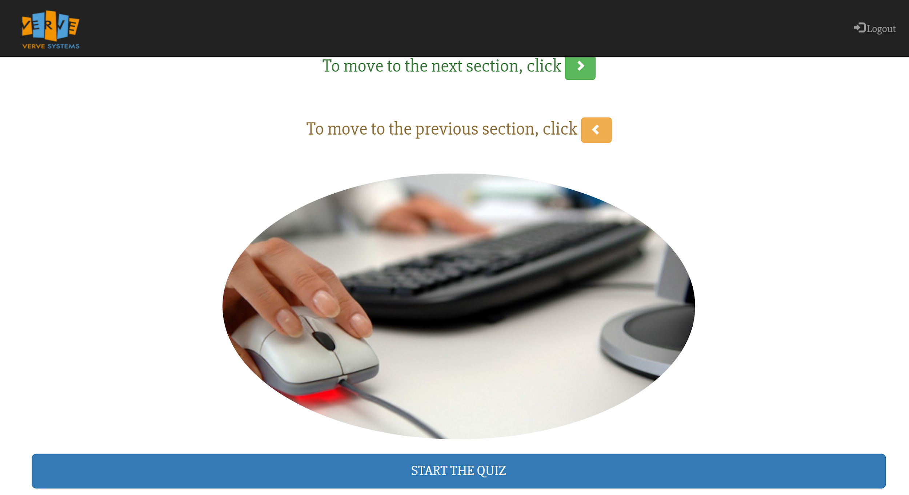

16. Start the quiz and hit next when all questions on the page are answered:

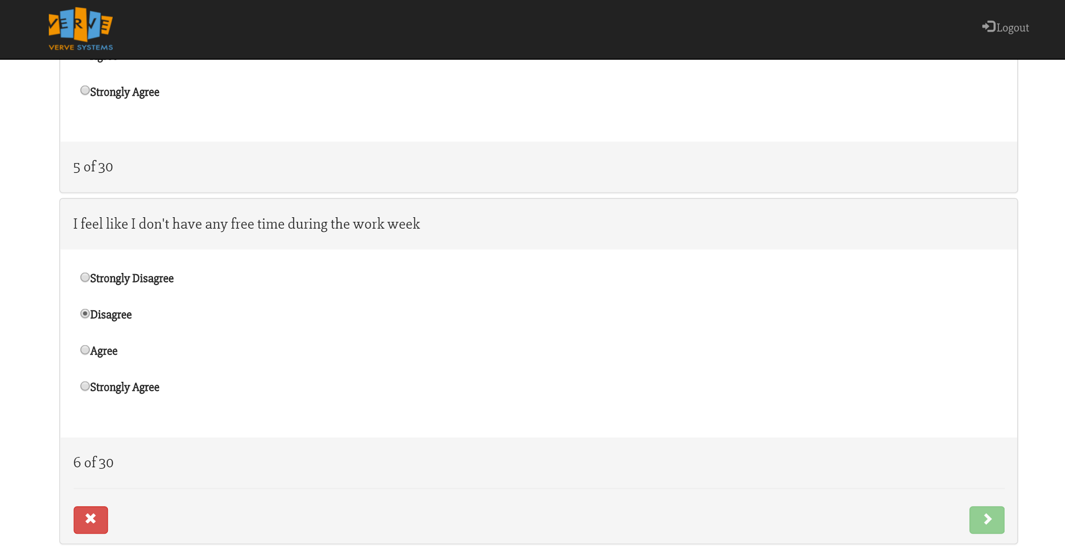

17. You are allowed to exit and go back to previous questions. If you exit however, all of the work will be lost:

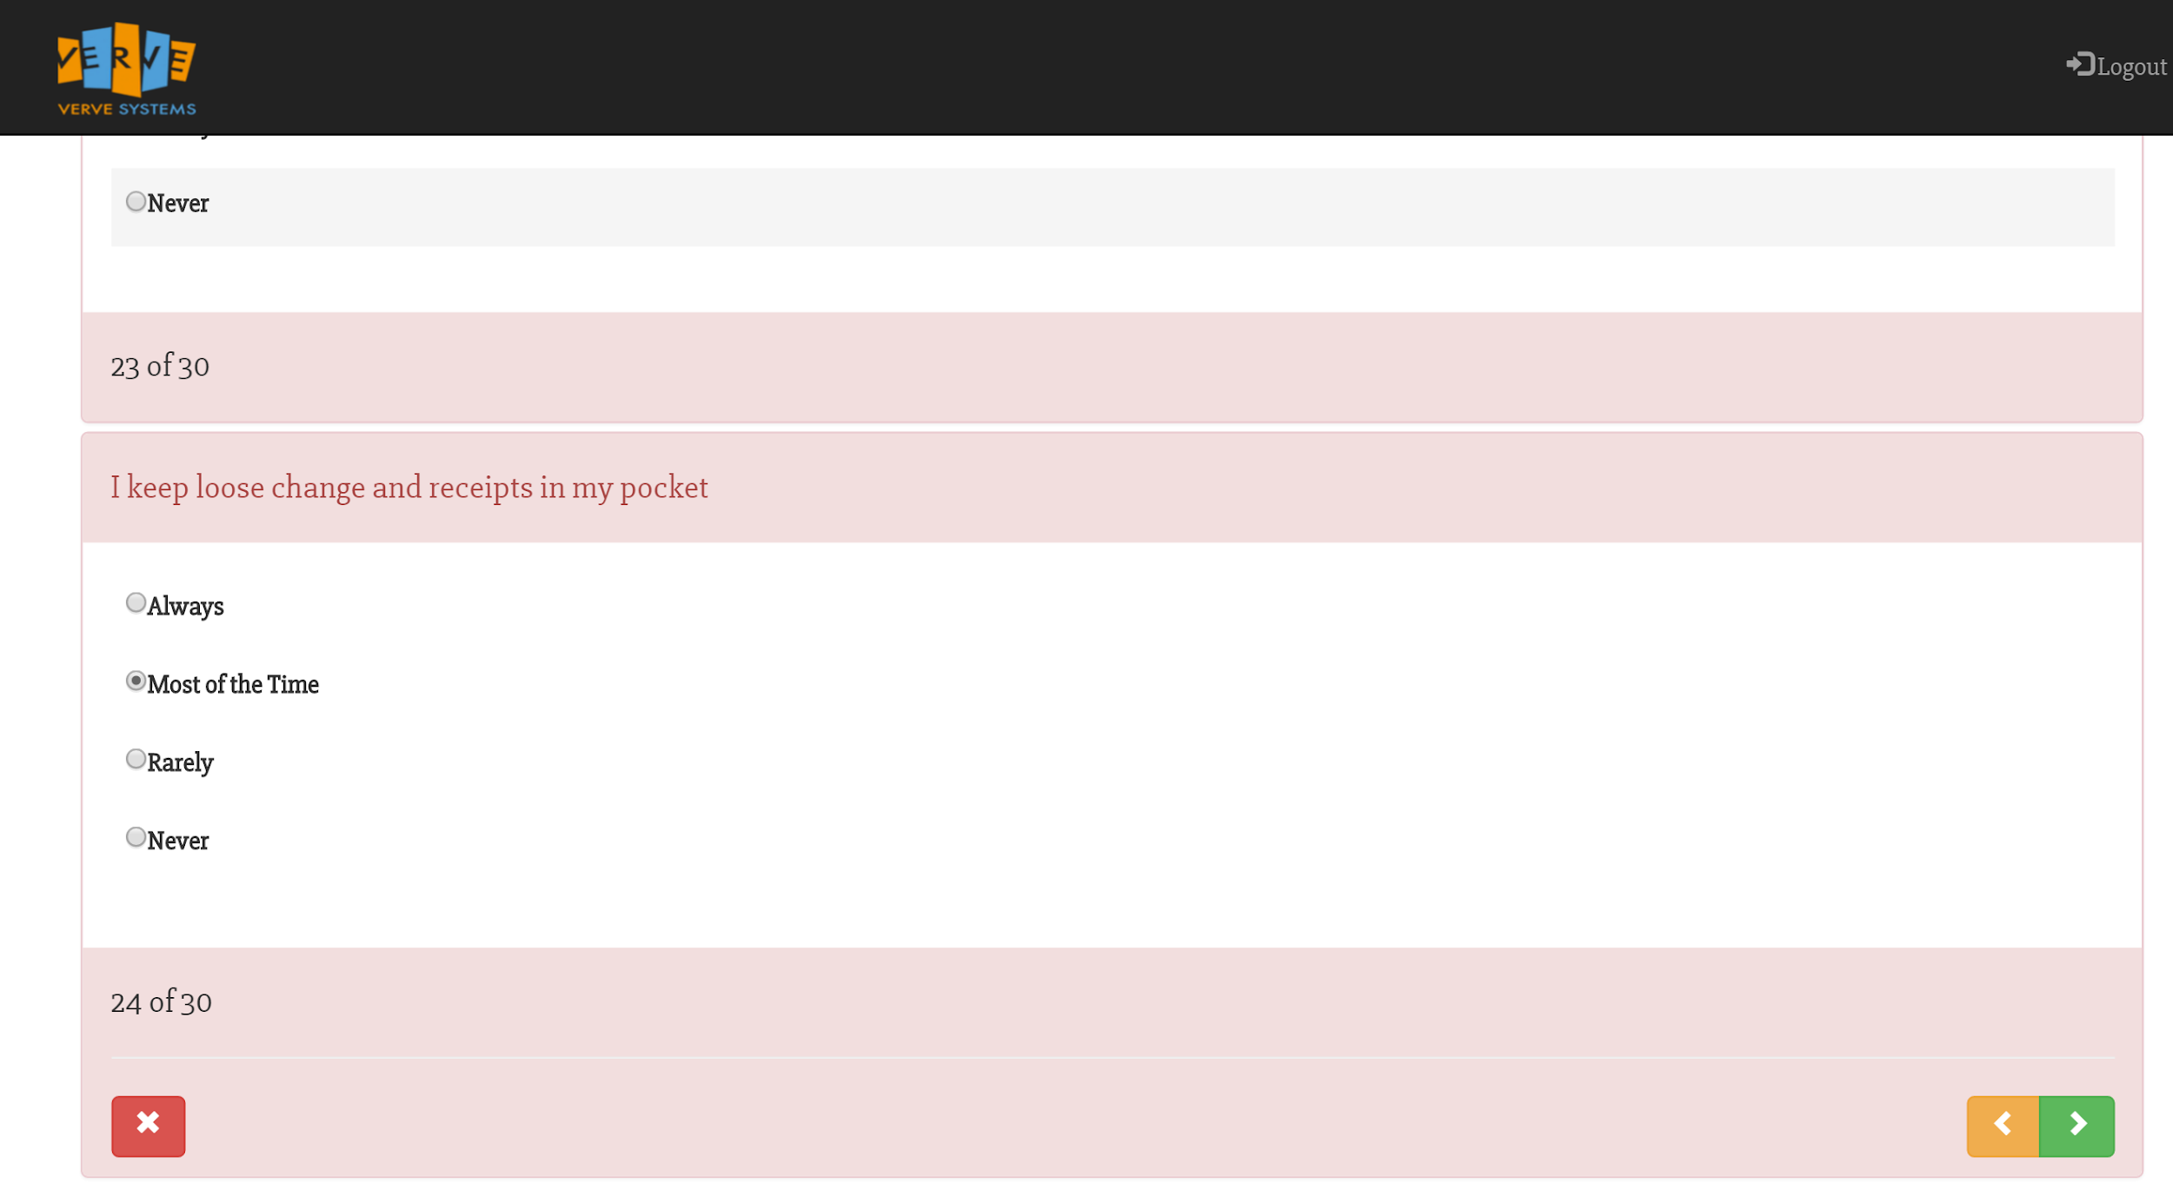

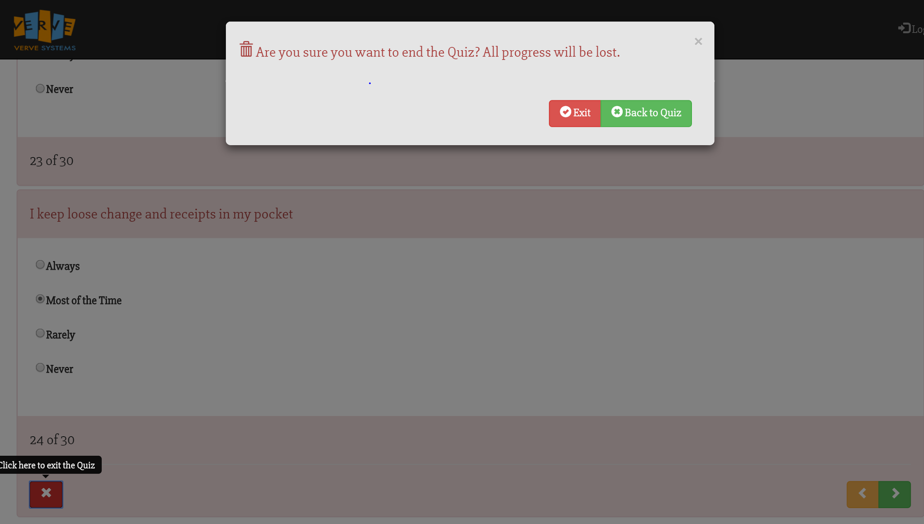

18. When finished, hit the blue send button:

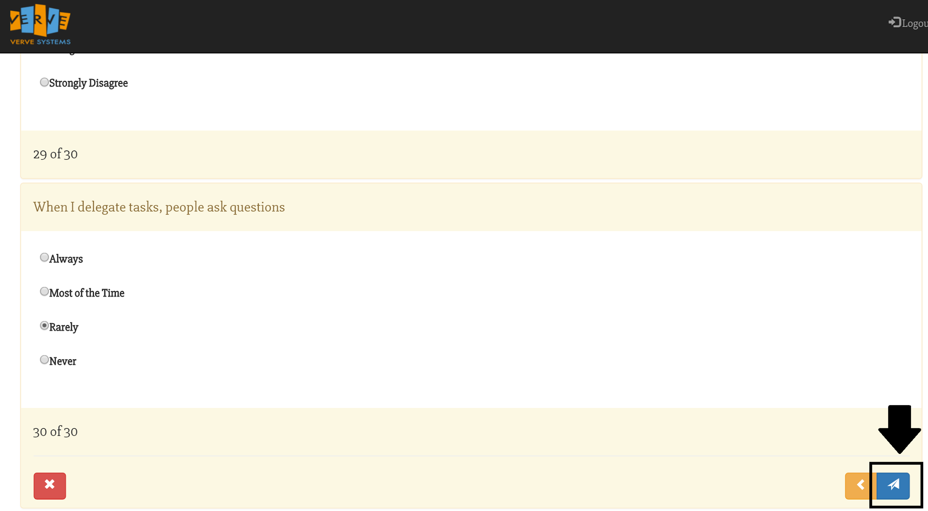

19. When you get results, training videos should be recommended. Clicking them will take you to a video training.

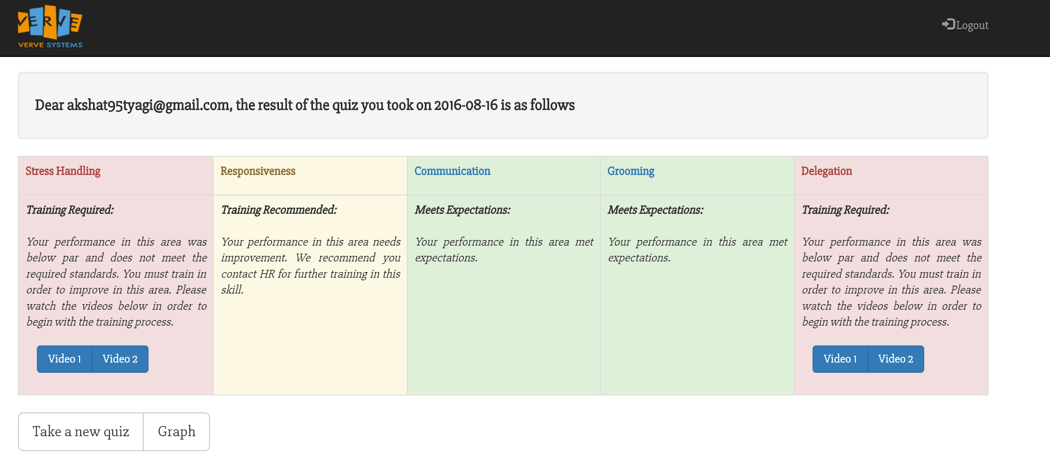

20. A graph is available to gauge how well the user did in relation to the other sections:

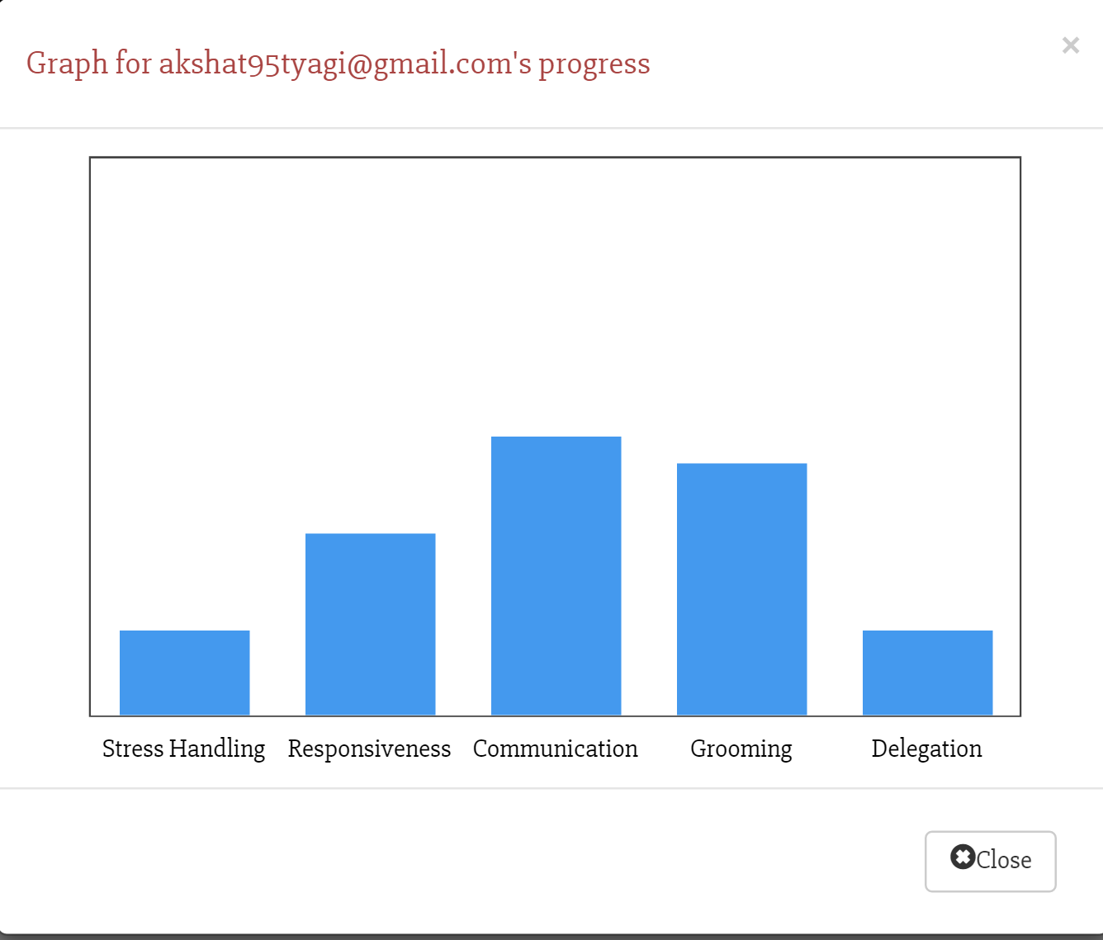

Lastly, an email will be sent to indicate the employee’s results:

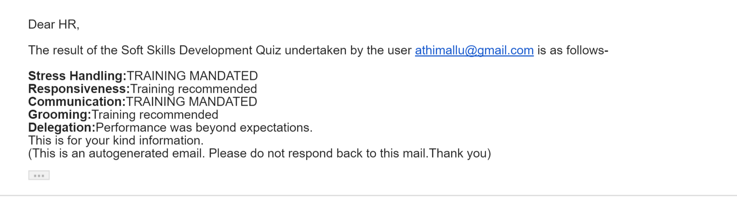

* Appendix H - Meeting Log

|  |  |  |  |  |
| --- | --- | --- | --- | --- |
| Date | Time Start | Time End | Purpose | Items Accomplished |
| 6/29/16 | 9:30:00 PM | 11:47:00 PM | Team Building | Team Building |
|  |  |  | Team Contract |  |
|  |  |  | HW 1 |  |
| 7/5/16 | 11:30:00 AM | 12:06:00 PM | Intial Team Kick Off | Zoom Meeting with CEO of Verve |
| 7/5/2016 | 9:00:00 PM | 11:00 PM | Initial Project Proposal | Project Information, Project Goals, Project Description, Project Deliverables, Project Resources and Roles |
| 7/7/2016 | 6:00:00 PM | 7:15 PM | Complete Initial Project Proposal | Sent meeting time to Nitin, Completed Project Proposal |
| 7/12/2016 | 9:00 AM | 10:00 AM | Video Conference with Nitin Bawsay for introduction | Initial contact with Nitin |
| 7/12/2016 | 9:00 PM | 11:03 PM | Develop questionnaires | Completed and sent out questionnaire to verve systems |
| 7/18/16 | 9:00 PM | 11:00 PM | Go over questionnaire/Set up times for interviews with employees | Highlighted potential employees to interview/ Sent out interview times |
| 7/19/2016 | 9:00 PM | 11:05 PM | Develop interview questions/Initial Contact with Amity | Develop interview questions/ barebones survey logic for softskills identification/intro email to Amity |
| 7/21/16 | 8:00 AM | 9:00 AM | Introduction to Amity Team | Introduction with Amity Team/ Initial project Development |
| 7/22/16 | 8:00 AM | 9:00 AM | Video Conference with Nitin Bawsay, Project Sketch | Showed Initial Survey Project Proposal Part 1 |
| 7/26/16 | 9:00 AM | 10:10 AM | Video Conference with Amity | progress update with Amity Team on soft skills identification quiz/assigned weights to quiz |
| 7/26/16 | 11:00 AM | 12:45 PM | Update Questionnaire | Finished updating questionnaire |
| 7/26/16 | 9:00 PM | 11:00 PM | Revise Initial Project Proposal/Research Training Videos | Completed Revised Project Proposal and Researched potential training videos |
| 7/27/16 | 1:00 AM | 1:30 AM | Sahir & Wingkin Interview of Verve Employees | Completed video interview of employees |
| 7/29/16 | 1:00:00 AM | 2:00 AM | Tim, Nirali & Athira Interview of Verve Employees | Completed video interview of employees |
| 8/2/16 | 9:00 AM | 10:00 AM | Video conference with Amity | Follow up with web application from Amity Team. First impressions |
| 8/2/16 | 9:00 PM | 10:30 AM | Follow up with Amity Team/ Begin Final Proposal | Sent email to Amity for clarification/ delegate task for final proposal |
| 8/8/16 | 9:00 AM | 10:00 AM | Meeting with Amity: final deliverable | Consulted with Amity Team for small UI designs |
| 8/9/16 | 9:00 AM | 10:00 AM | Web App Walkthrough with Nitin | Obtained feedback for more UI designs on web app |
| 8/9/16 | 9:00 PM | 11:00 PM | Continue Final Proposal/ Begin Final Presentation | Continue Final Proposal/ Begin Final Presentation |
| 8/11/16 | 9:00 PM | 11:20 PM | Continue Final Proposal/ Begin Final Presentation | Continue Final Proposal/ Begin Final Presentation |
| 8/15/16 | 9:00 PM | 12:00 AM | Continue Final Proposal/ Continue Final Presentation | Continue Final Proposal/ Continue Final Presentation |
| 8/16/16 | 9:00 AM | 10:00 AM | Practice Presentation with Amity | Practice Presentation with Amity |

**Work Cited/References** (APA Style - ) – please include a work cited section in APA format that outlines all resources used in your document. Include all interviews, surveys, journal articles, books, websites, course content etc. (if any)

#### *15 Effective Time Management Tips For IT Professionals*. (2016). *YouTube*. Retrieved 3 August 2016, from <https://www.youtube.com/watch?v=lK21gEO14AQ&feature=youtu.be>

#### *Business Etiquette Quiz - Test Your Business Etiquette - GradView*. (2016).*Gradview.com*. Retrieved 3 August 2016, from <http://www.gradview.com/articles/careers/etiquette.html>

#### *Be Responsive, Be Successful*. (2010). *1000 Diamonds*. Retrieved 3 August 2016, from <https://1000diamonds.wordpress.com/2010/09/13/be-responsive-be-successful/>

#### *Careers | Top 10 Soft Skills in DemandLiveCareer*(2016).*LiveCareer*.Retrieved 3 August2016,from <https://www.livecareer.com/career-tips/career-advice/soft-skills-in-demand>

#### *Centennialcollege.ca*. Retrieved 3 August 2016, from <http://www.centennialcollege.ca/pdf/gradsuccesspack/JobOffer/busetquiz.pdf>

#### *Coping With Stress at Work*. (2016).*http://www.apa.org*. Retrieved 3 August 2016, from <http://www.apa.org/helpcenter/work-stress.aspx>

#### *Consult-smp.com*. Retrieved 3 August 2016, from <http://consult-smp.com/wp-content/uploads/2013/10/Delegation.pdf>

* ***Dress and Grooming for Job Success - Career Connections Center : Columbus Technical College*. (2016).*Columbustech.edu*. Retrieved 3 August 2016, from** [**http://www.columbustech.edu/career-connections/attire.htm**](http://www.columbustech.edu/career-connections/attire.htm)

#### Dugan, D. (2016). *7 Signs You Have Terrible People Skills*. *Salary.com*. Retrieved 3 August 2016, from <http://www.salary.com/7-signs-you-have-terrible-people-skills/>

#### *Grooming Quiz*. (2016). *ProProfs*. Retrieved 3 August 2016, from <http://www.proprofs.com/quiz-school/story.php?title=grooming-quiz>

#### *How Well Do You Delegate?: Discover Ways to Achieve More*. (2016).*Mindtools.com*. Retrieved 3 August 2016, from <https://www.mindtools.com/pages/article/newTMM_60.htm>

#### Hutton, L. (2014). *6 Reasons Why Effective Communication Should Be a Focus in Your Business | AIB Official Blog*. *Official Blog - Australian Institute of Business*. Retrieved 12 August 2016, from <http://aib.edu.au/blog/6-reasons-effective-communication-focus-business/>

#### *How Well Do You Delegate?: Discover Ways to Achieve More*. (2016).*Mindtools.com*. Retrieved 3 August 2016, from <https://www.mindtools.com/pages/article/newTMM_60.htm>

#### *How To Deal With Stress At Work*. (2016).*YouTube*. Retrieved 3 August 2016, from <https://www.youtube.com/watch?v=GYx0DZKth-8>

#### *How to Stay Stress Free In Stressful Situations At Work*. (2016). *YouTube*. Retrieved 3 August 2016, from <https://www.youtube.com/watch?v=4BKDYKgQ_ZU&feature=youtu.be>

#### *How To Look Professional At Work*. (2016).*YouTube*. Retrieved 3 August 2016, from <https://www.youtube.com/watch?v=7vc7Bxcu4Rc&feature=youtu.be>

#### *How To Delegate Tasks Like a Pro: Team Task Management Tips*. (2016). *YouTube*. Retrieved 3 August 2016, from <https://www.youtube.com/watch?v=KApy2bpDMaQ>

#### *IT Industry in India, Indian Information Technology, ITeS Sector, Services*. (2016). *Ibef.org*. Retrieved 12 August 2016, from <http://www.ibef.org/industry/information-technology-india.aspx>

#### *Improving Communication in the Workplace - Communication Style*. (2016).*YouTube*. Retrieved 3 August 2016, from <https://www.youtube.com/watch?v=xo4pljolYD8>

#### *Professional Appearance and Grooming for the Workplace | Future of Working.com*. (2016).*Futureofworking.com*. Retrieved 3 August 2016, from <http://futureofworking.com/professional-appearance-and-grooming-for-the-workplace/>

#### *Professional Appearance and Grooming for the Workplace | Future of Working.com*. (2016).*Futureofworking.com*. Retrieved 3 August 2016, from <http://futureofworking.com/professional-appearance-and-grooming-for-the-workplace/>

#### *Personal appearance is everything*.*YouTube*. Retrieved 3 August 2016, from <https://www.youtube.com/watch?v=s6p4nLtC-fM>

#### *Robust growth for the Indian IT-BPM Industry | NASSCOM*. (2016). *Nasscom.in*. Retrieved 12 August 2016, from <http://www.nasscom.in/robust-growth-indian-itbpm-industry>

#### *Stress at Work: How to Deal with Job and Workplace Stress*. (2016). *Helpguide.org*. Retrieved 3 August 2016, from <http://www.helpguide.org/articles/stress/stress-at-work.htm>

#### Sharma, M., Sharma, M., & profile, V. (2009). *Soft skills in life and work: Personal grooming and Etiquettes*.*Softskillsinlifeandwork.blogspot.com*. Retrieved 3 August 2016, from <http://softskillsinlifeandwork.blogspot.com/2009/08/personal-grooming-and-etiquettes.html>

#### *Stress in the Workplace | Skills You Need*.*Skillsyouneed.com*. Retrieved 3 August 2016, from <http://www.skillsyouneed.com/ps/workplace-stress.html#ixzz4GE9ASdAh>

#### *The importance of personal grooming*. (2012). *The Real Power*. Retrieved 3 August 2016, from <https://therealpower.wordpress.com/2012/12/27/the-importance-of-personal-grooming/>

#### *The Importance of Responsiveness*. (2015).*Inc.com*. Retrieved 3 August 2016, from <http://www.inc.com/eric-holtzclaw/the-importance-of-responsiveness.html>

#### *Using the Eisenhower Matrix*. (2016).*YouTube*. Retrieved 3 August 2016, from <https://www.youtube.com/watch?v=suGXZ1869qc>

#### *What Is Non Verbal Communication, And How Can It Help Me*. (2016).*YouTube*. Retrieved 3 August 2016, from <https://www.youtube.com/watch?v=K8PTApmd_wE&feature=youtu.be>